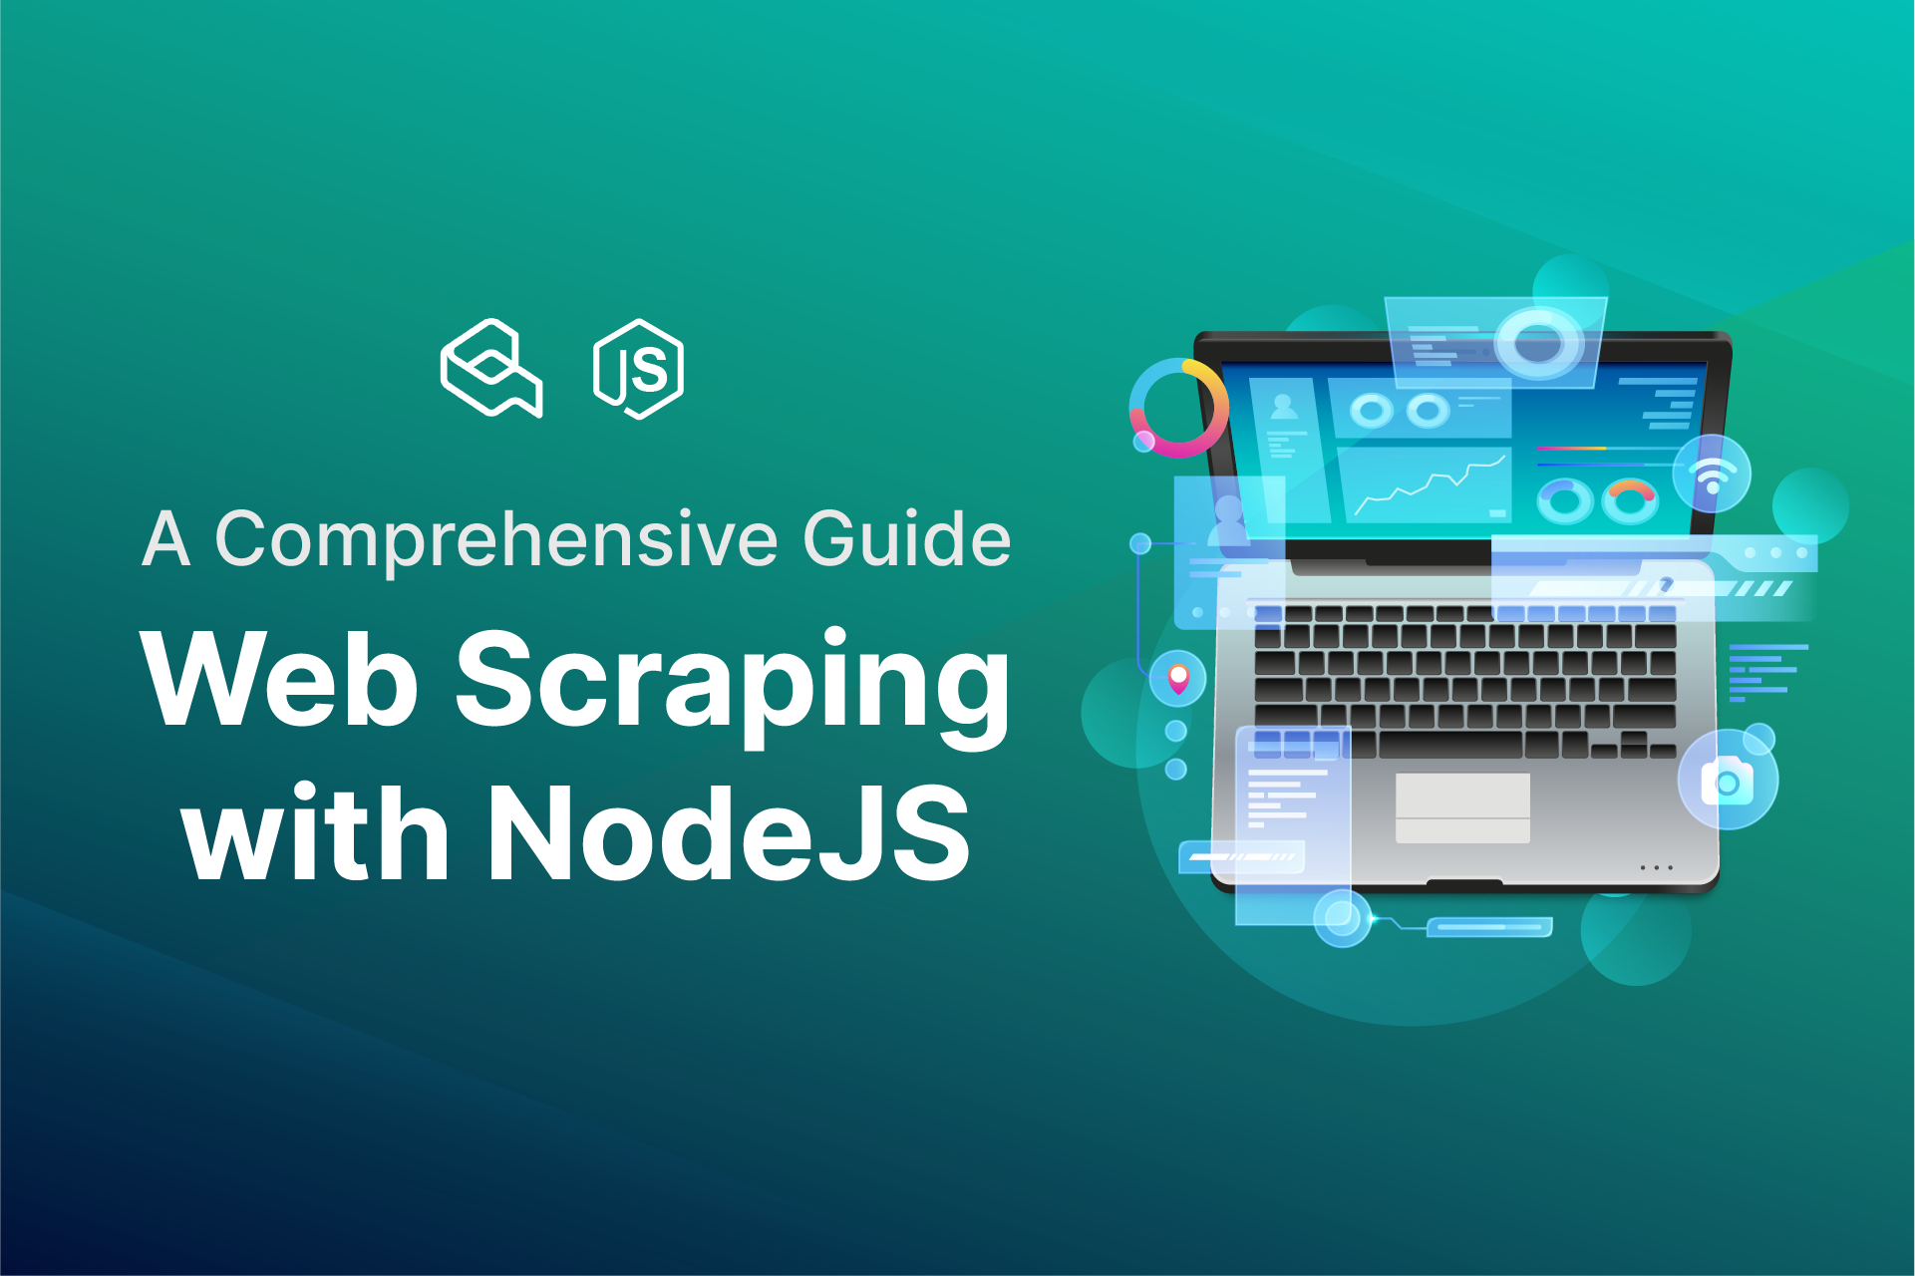

**Web Scraping with NodeJS: a comprehensive guide**

This blog is about the Node js course on web scraping, where you will learn how to scrape any type of website and by using a real-world example. This blog will teach you strategies and practices that you won't find anywhere else. You'll be able to quickly grasp all of the ideas and move from the examples and also, you will be able to make your scraper by the end. This blog post is aimed to assist anyone interested in learning web scraping with NodeJS because the issue with any other blog tutorials is a little challenging and you don't always find everything you need in one place.

**Requirements**

The sole and only requirement you need is that you have to have a basic understanding of Javascript or are at least familiar with it, as this will be the only programming language we are going to utilize. I would also recommend reviewing the async and await syntax in es6 and higher, as we'll be using it a lot.

**Tools**

Also, if you're wondering what sorts of tools we will be using then, we will be utilizing vscode which is a free code editor that also supports NodeJS debugging without the need to install extra complicated plugins. We'll also utilize a variety of libraries, as well as different libraries, but we'll mostly use puppeteer, which was built and is maintained by the Google team, and also we will be using NighmareJS as well.

**Tools and Project Setup.**

Before we begin creating our scraper program, we must first set up our environments by downloading our editors and NodeJS, as well as complete some basic project setups before we can begin writing code. So first, go to the official VS code website,[code.visualstudio.com](https://code.visualstudio.com/), and download and install the VS code editor which is available free of charge. The key reason to use Visual Studio Code is that it is free and comes with a built-in debugger for Nodejs, making debugging a hundred or even thousand times easier.

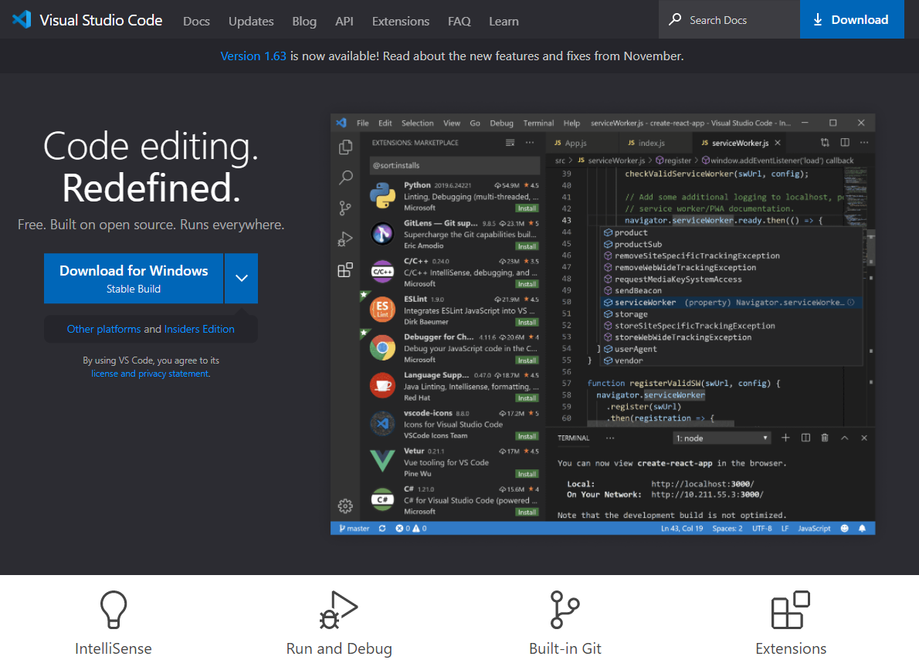

After installing our VS code editor, we must ensure that we have Nodejs installed to run our Nodejs application on our machine. Nodejs can be downloaded from nodejs.org and is compatible with both macOS and Windows, with a simple installation process. All you need to do now is download the package and follow the simple installation instructions.

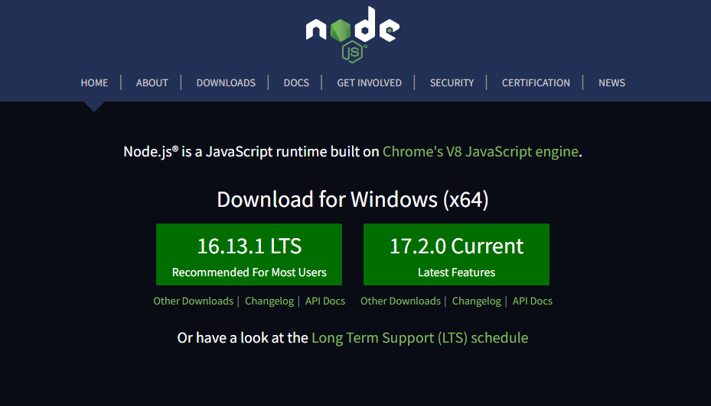

Also, if you want to see what version of Nodejs you have installed, go to the terminal/command line and type "node -v" which will tell you what version of Nodejs is currently installed on your computer. If this command doesn't work, make sure you restart your computer after installing Nodejs.

Now that you've completed this, go to our VScode and open an empty folder in it, then open the terminal inside it and run the “npm init -y” command to initialize our project. So now you can see that a new "package.json" file has been produced within that folder, and we can just start installing and using our libraries right away and start making use of them. Also, inside that folder, create a new file called index.js, which will be our entry file, and now we're ready to write some code inside it. This is how your file structure should now look.

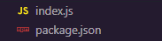

**Simple IMDB movie scraper.**

We'll be building a simple IMDB scraper that parses the data from the IMDB movie page. This is just one of many real-world examples we've included in this particular section of the blog to give you gist and an idea of what can be accomplished in a short amount of time, so don't worry about getting too many details in this example because we'll go into more depth in the upcoming examples.

So we'll use NodeJS to send a direct request to the IMDB website and expect a response that looks exactly like the image below. To begin, navigate to the IMDB website, right-click, and then select "View page source."

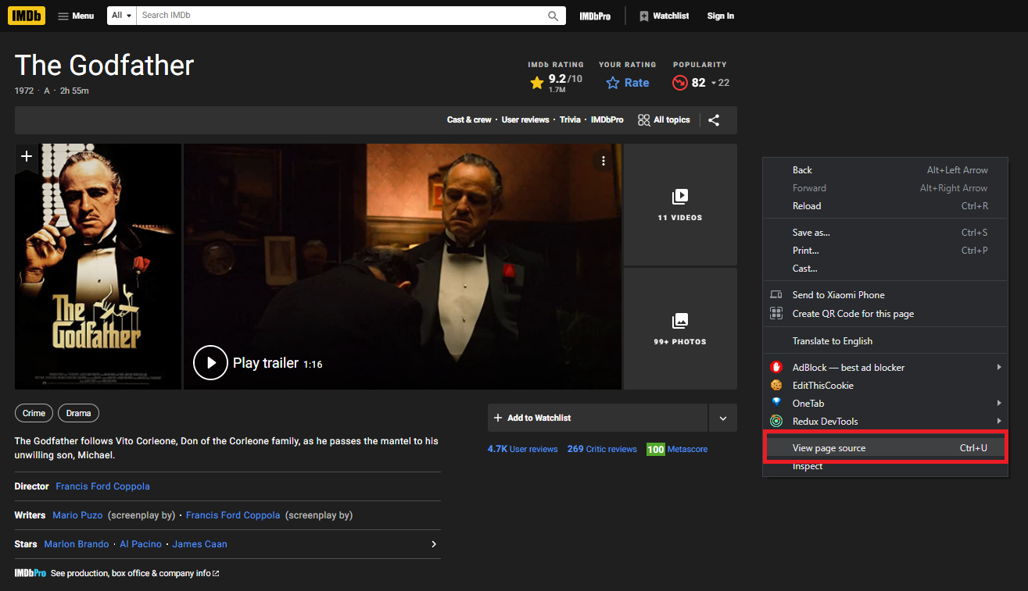

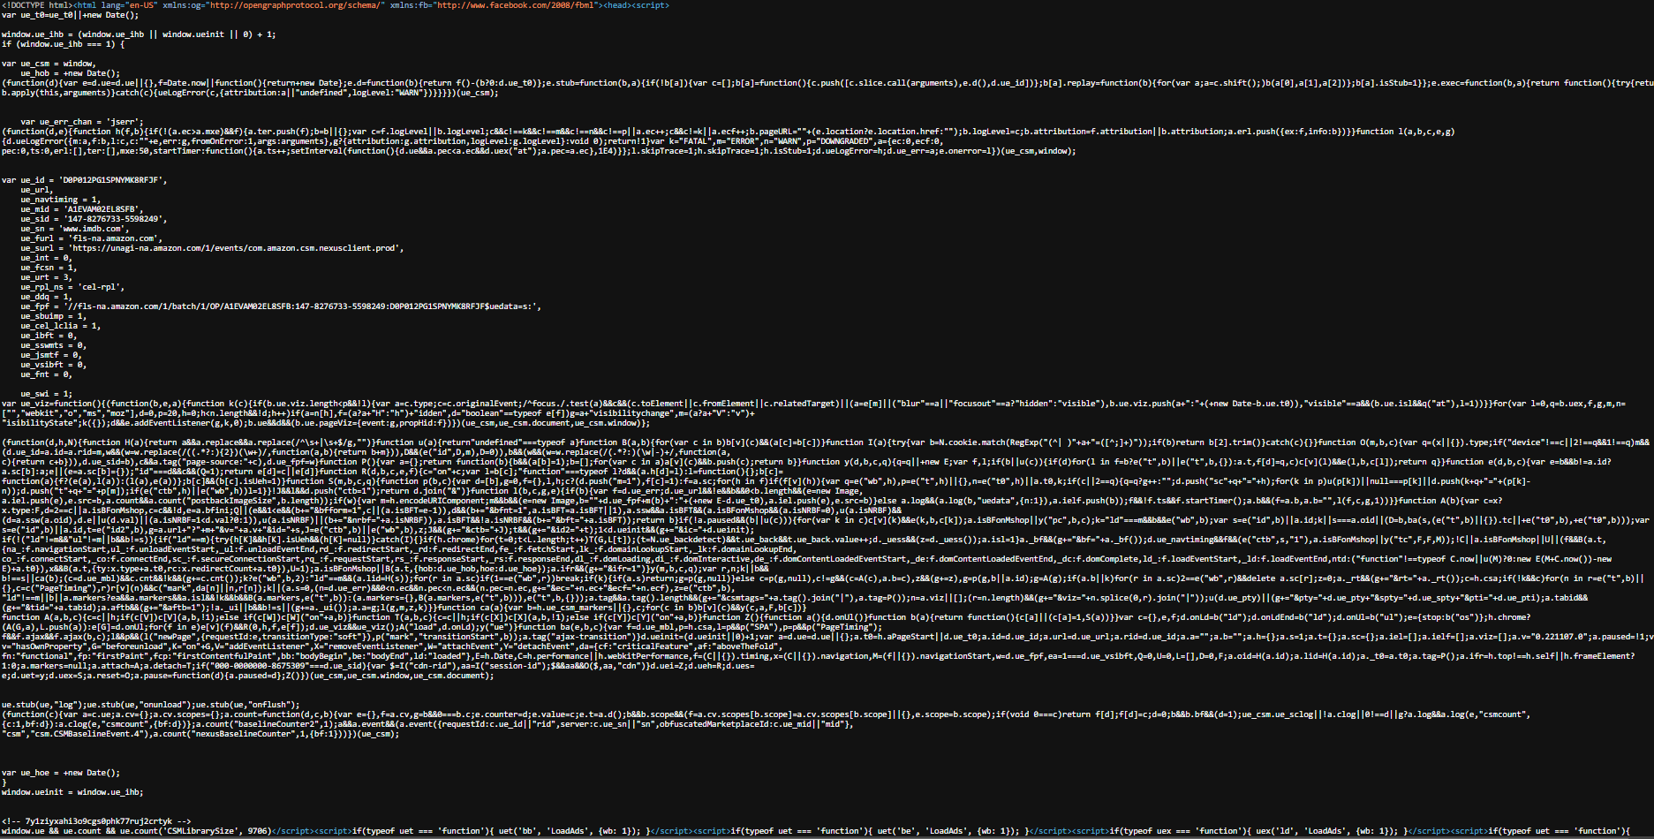

As you can see, this is the exact HTML content with Javascript and CSS that we will scrape using our NodeJS scraper. Following that, we will use Cheerio JS, a Nodejs library that can handle HTML content and has a syntax that is nearly identical to jQuery. It would be preferable if you were already familiar with the jQuery syntax. To begin, we must import both the request-promise library, which is in charge of managing requests to the IMDB website and the Cheerio JS library, which will be used to parse the HTML contents.

Now, make sure you're in the "index.js" file that we previously created, and begin importing the actual libraries inside it.

| const request = require("request-promise"); const cheerio = require("cheerio"); |
| --- |

The next thing we're going to do is go to the IMDB website and copy the URL of whatever movie you want because we're going to send the request to that specific URL, so simply create a variable named URL and paste that specific copied URL link inside it.



| const URL = "https://www.imdb.com/title/tt0068646/?ref_=fn_al_tt_1"; |
| --- |

Because we cannot write the asynchronous function in the index unless it is declared as async, we must now write the simple async function that will be accessed when the NodeJS scrapper is fired. Simply create a nameless asynchronous function that will be executed automatically. Before we write anything inside that async function, we must first install the request-response and cheerio libraries. To do so, go to the terminal and type the following command.

npm install cheerio request-promise

After installing the package, it should look something similar to this.

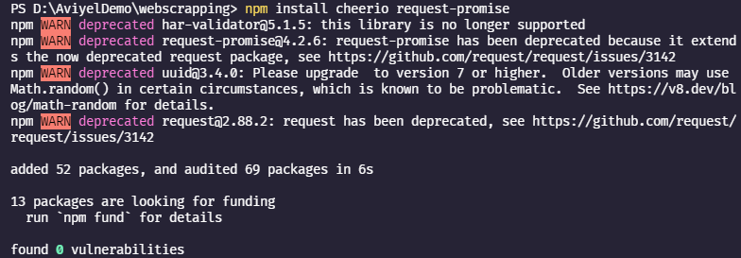

So, now that we have everything installed and ready to go, we can use the request library. To do so, create a variable called response and inside it simply wait for the request to be completed while also passing the URL as its parameters. To test the response, simply console log it; we should be able to see the raw response. So, to run it, go to the debugging tab and press the run button.

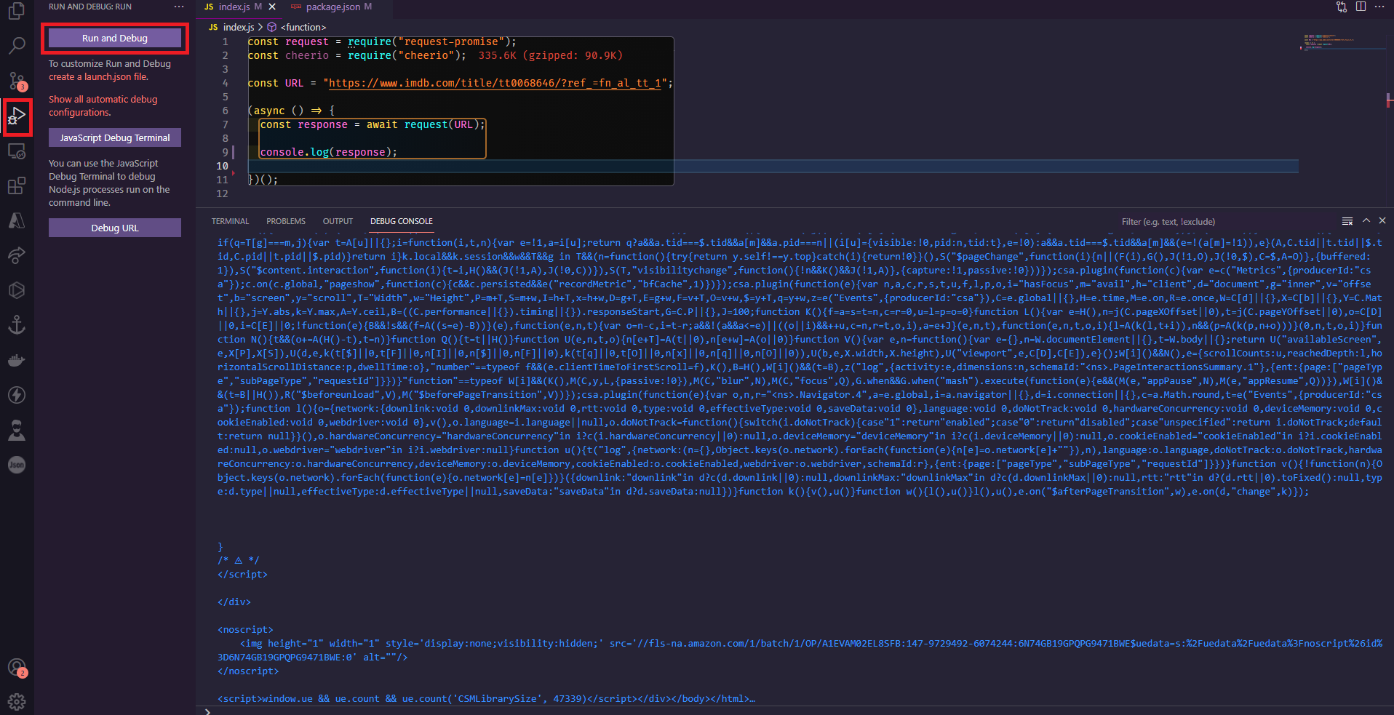

As you can see, it worked; we got what we needed, which means the script was successful, and we can now begin passing our response to the cheerio library and using it to go through each of the HTML properties and find out exactly what we need.

First, let's get rid of the console log and implement the cheerio library.

| let $ = cheerio.load(response); |
| --- |

We simply created a “$ (dollar)” variable responsible for the cheerio with the actual IMDB response. Now we can begin writing the scraping for the movie title. First, go to the movie that you want to scrap. So, right-click on the title and select Inspect Element.

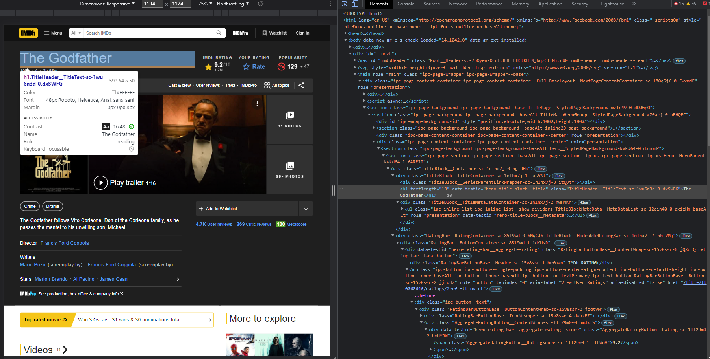

Then we have the div element and inside it, there is an h1 as well as span element, which contains the title of the movie as well as the ratings of the movie. We can select the element by using the jQuery syntax-like selector as shown in the code below.

| let title = $("section.ipc-page-section > div > div > h1").text(); let rating = $(  "div.ipc-button__text > div > div:nth-child(2) > div > span"  ).text().slice(0,6);  console.log(`"${title}" movie has an IMDB rating of ${rating}`); |
| --- |

If you select the debug option again, you should see something similar to this.

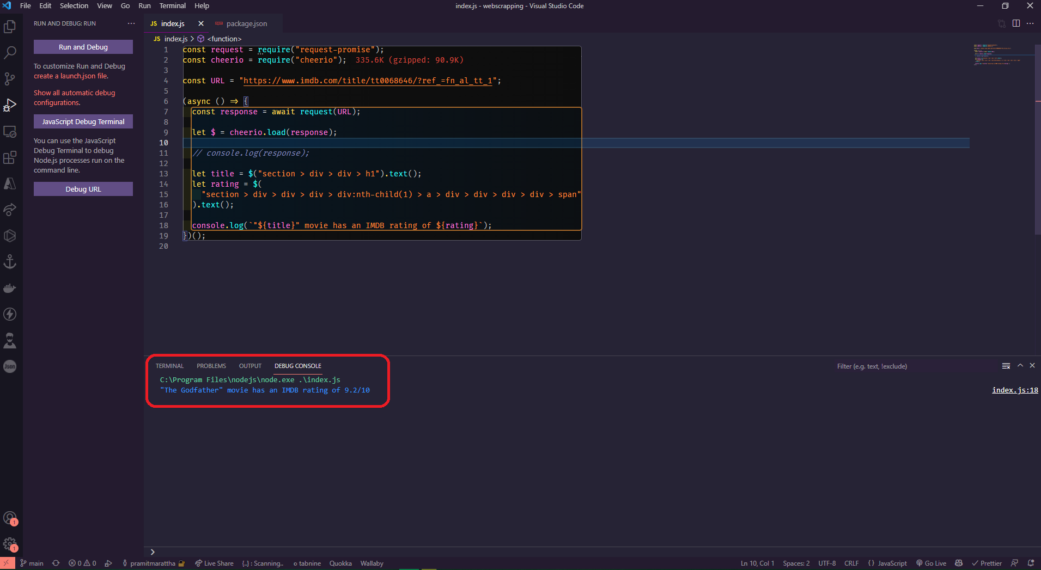

So, now that you have enough information to get started with web scraping, let's delve into much more detail.

**Why and when should you scrape a website?**

So, before you begin creating a scrapper for your website, you should ask yourself

* "What data do I need from that particular website ?",
* "Do they have an API for that? ",
* "Do they provide all the information that I need ?",
* "Do they have any limitations that will stall your results ?",
* "Do I have to pay to send the request to their server ?"

So, if you ever find yourself in a situation like this, where you believe you will not benefit from an official API due to the reasons stated above, or if there is a specific website that does not even have an API, you should consider creating a scrapper.

What we did previously is a perfect example, where we wrote a straightforward IMDB scrapper. Because IMDB does not have an official API that is accessible to the public, we relied on scraping the data. Of course, the scrapper that we wrote is very basic, but it demonstrated the possibility and power of scrapping with Nodejs. To give you a hot tip, we will explore the IMDB scrapper and write an even more complex scrapper later on.

Before we begin, we must understand when it is appropriate to scrape data from a website. Keep in mind that web scraping is not always an ethical solution, nor is it always a black hat solution; it falls somewhere in the middle. That is to say, web scraping is not illegal, but it can get you in trouble if you violate someone else's website or organizational policies. So, before you plan to scrape a website, you should look at the terms and services of that particular website and see if they have anything related to scraping the data from their website; if they do, it means they may not want you to do it, and if they don't, it means they don't care if you scrape their website or not. Also, before you scrape, you should ask for permission to scrape it. Also, before you start scraping other people's or companies' websites, you should respect their data by using official APIs whenever possible, not spamming their website with an excessive number of requests, and finally, if you want to monetize the scrapped data, always seek legal advice and make sure what you're doing with it is completely legal.

**The most significant issue with scraping**



The most difficult and inconvenient aspect of web scraping is the maintenance and stability of the scrapper. These are the issues that you may have to deal with when building a scrapper. Scrapers can be useful for a variety of things such as extracting data, parsing, and so on. Let's say you wrote a scrapper and it works fine until it doesn't and you encounter some random error, which is exactly the problem, so it can work for one day, one month, or even one year before failing. The main issue with this is that the website that you are currently scraping can constantly change, its structure can change, and their system can change, and also the URLs of the website As a result, you have no control over it, and your scrapper may fail at any time due to this issue. When writing or coding scrappers, the logic and workflow are based on the current website you are attempting to scrape and its structure, so if the website decides to change its entire structure, you may have to change the entire structure as well as the logic of the scrapper as well. Of course, if you still want to make it work, you may be wondering how to solve this type of problem. The short answer is that you cannot change this type of problem because you have no control over the website you are attempting to scrape; you must simply deal with the problem that arises. This is why you must learn how to develop a scrapper quickly and efficiently, as well as how to debug and fix problems. This type of problem can occur on both a small and large scale, so you must be prepared at all times.

**Request Method with the assistance of the Request Library**

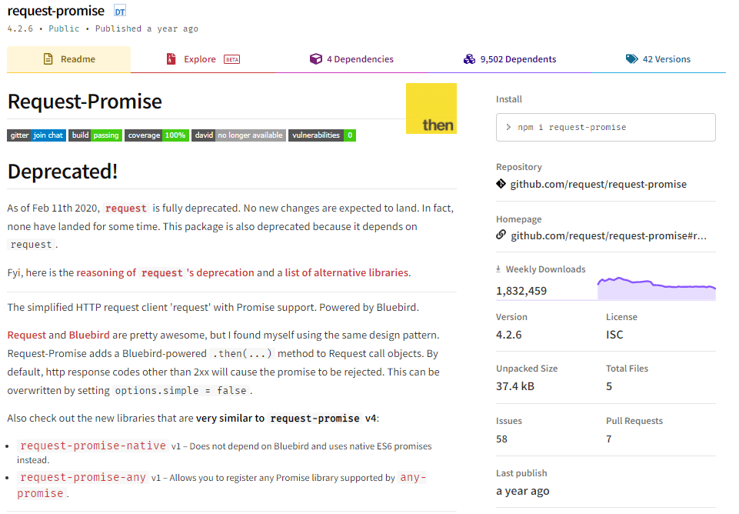

In this section, we'll go over the request-promise library, what you can do with it, and when it's best to use it. So, what exactly are we able to do with the request library? We're incorporating this library into our earlier project that we did. We use this library because the "request" library allows us to submit requests to the server in the simplest and fastest way possible. Before we begin, let's look at some examples. So, when you visit a website, a basic GET request to the server is sent first, followed by the initial content, the HTML response. So, with the request library, you can do the same thing, but instead of using the browser, you can write the action in Nodejs and it will do everything for you.

Let's take another example: when you want to login and enter your username and password into a specific website, a POST request is sent to the server, which sends the details of your entered account to the server for confirmation. This can also be done manually in Nodejs by simulating every or any request the browser makes to any website; all we have to do is provide the right parameters to it. In the case of the IMDB scraper, we used it as a GET request to obtain HTML and parse it.

**Benefits and Drawbacks of Request Library**

Since you control every parameter that you send to the server, it can be a little overwhelming at times. Let's use the previously described login process as an example. So, as previously described, the login process can consist of a single simple POST request to the server with the username and password depending on the website, followed by a single response with some cookies or a token in such case the request method is ideal, or the login system can consist of multiple requests on a simple login form on some websites can automatically send multiple requests for security reasons or because of how they were originally built on and In that case, you do not want to use the request library but of course, it is feasible, but it is very time-consuming and can be extremely frustrating, and many things can go wrong, such as missing simple parameters in the request headers and the server you are currently attempting to reach refuses to accept it. It all depends on the situation, but it is strongly discouraged to use this library if you have a large number of requests to send. Hence, if the website is more complex and automatically sends AJAX requests with different parameters and tokens, the best method would be to use the headless browser, which we will cover in detail in the following upcoming sections.

Therefore, only in simpler times, you should use the request library, but when the website has loads of security behind it and is dynamically rendered, you should probably use another method or even a headless browser method.

**Scraping with a browser automation approach**

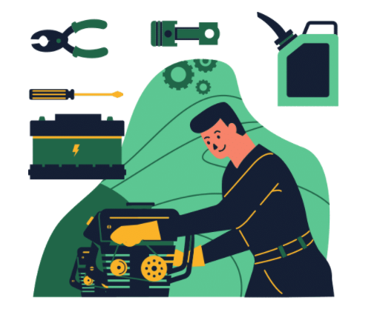

In this section, we'll deep dive into browser automation and how it might be applied for developing a scraper. But first, let's define browser automation. Browser automation, in our case with the help of NodeJs, essentially means controlling the browser using code. Now that you know that certain browser engines support this, you can see that you can't just automate your regular browser; instead, you'll need a browser that allows you to manage it using code, and we'll look at a plethora of examples in the upcoming topics ahead.

**Benefits and drawbacks of employing browser automation.**

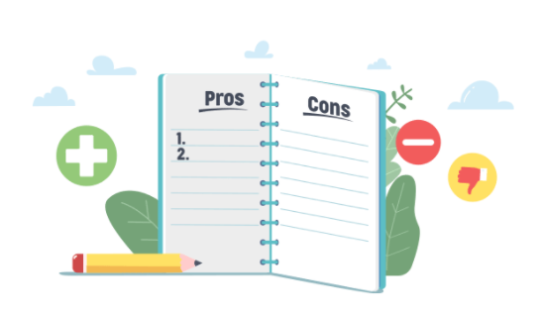

Before we get started, let's quickly go over the benefits and drawbacks of using Browser automation. For starters, it's much more beginner-friendly, and it's very easy to understand the action of the steps that you need to take because they're the same as when you browse the internet; all you have to do is write the specific code and scripts that your automated browser will follow. In most circumstances, implementing the scrapper with the automated browser is much cleaner, and you may wind up writing less code than you would with the request approach, but this, of course, depends on the page that needs to be scraped and what you need from it. The first disadvantage of this request approach is that you are essentially relying on the API availability of the individual browser you are automating. Others browsers have limited capabilities, and some aren't very stable, and some aren't even updated anymore, which is why you should be cautious and thoroughly study the browser before using it in your scrapper. So, before you decide whatever type of browser you want to automate, the browser's documentation will usually give detailed information.

**When is it appropriate to use browser automation for a scraping project?**

To begin, you must understand that there is no right or incorrect option. Any website may be done using requests, and the other way around. It all depends on how long it will take, how much code you will write, and how successful it will be. The browser automated scrapper will use more bandwidth and resources to load the page content from the website than the request method because the browser will load every CSS file, every javascript file, and every image that is on the website, whereas the request method will only get the HTML code for the website itself and will not load the external contents like files and libraries. So, if bandwidth and a few milliseconds of delay aren't important to you, browser automation is an excellent and perfect option for you. Browser automation makes things a lot easier while also saving you a lot of time.

**Browser automation libraries**

Before you begin, you must first decide which libraries to use. There are two excellent libraries available: Puppeteer and NightmareJS. There are many more libraries, although many of them are closed or abandoned.

Puppeteer is built on the Chrome browser and is also known as a headless version of Chrome. It was created specifically for automation, testing, and testing chrome extensions, among other things, but in our case, we will be using this library for scraping. This library is developed and maintained by the Google Chrome team and is a fully functional and up-to-date headless browser.

NightmareJS, on the other hand, is the electron browser's driver. It's a lot of fun to learn and even more fun to use, but it's not particularly suitable for complex scrappers. When compared to the puppeteer library, it has a lot of limitations. One of the library's biggest flaws is that it doesn't allow numerous tabs and links to open at once. As a result, libraries like this may break your scrapper or drive you to make compromises when you need them.

So, before you start scraping, let's go over a few things you might need to know. When you're running the scrapper and testing it, you can turn on the visual browser to see each action as it happens in real-time. This helps you understand and debug when you have a problem or when you're building a new scrapper. A competent headless browser will provide you with practically all APIs, allowing you to automate almost everything a user can do but by using the power of only coding and programming.

**IMDB scraper using a request method**

In this segment of the course, we'll delve a little deeper into the IMDB scraper that we constructed in the first session. We'll make it a little more complex as we go, and we'll learn new things along the way. With the request method, we'll learn how to spoof or fake user headers. So the main question is "why do we need to spoof them?" It's because we want it to appear that the scraper is a browser that's making the request. Request headers are extra parameters that the browser sends to the server automatically. They usually contain cookie information, such as whether you're logged in or not, and other types of browser information.

So, let's get started with how to check these. First, open the browser and right-click to open the developer tools. Right now, we need to go to the network tab to see all of the requests that are happening in this tab.

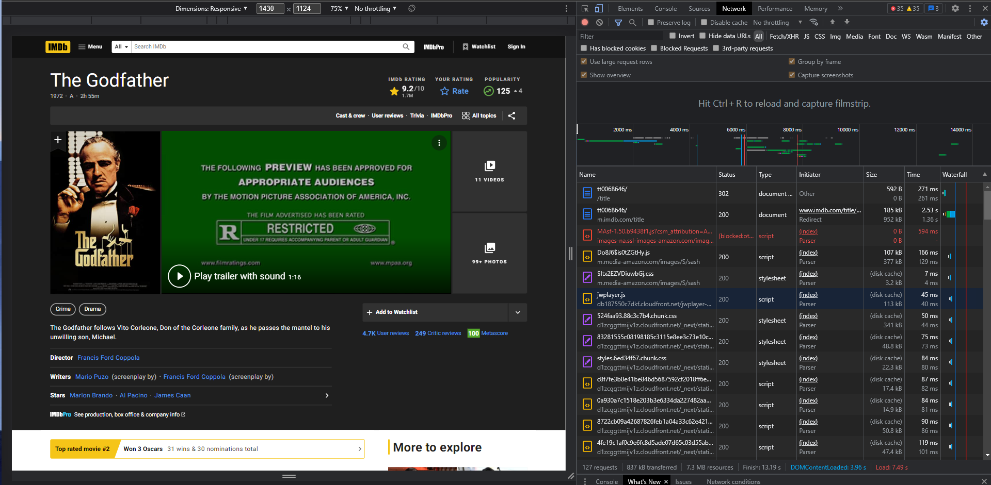

We may see a number of requests and their types here. There's the document, as well as images, graphics, style sheets, javascript, and a whole lot more.

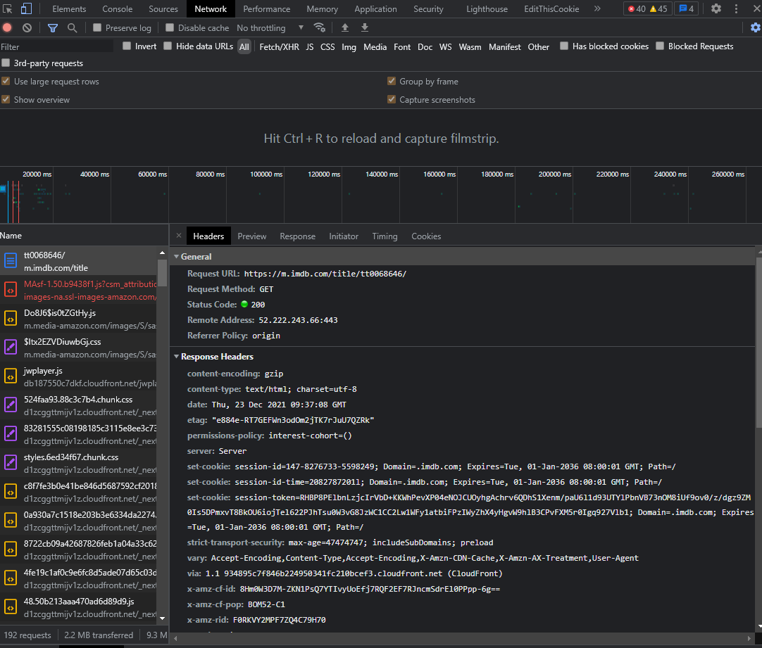

Let's take a look at the initial request that's being made, as you can see here. We can see the general information and the response headers, but we need to look at the request headers, which are a little farther down. Now we need to go to GitHub's request promise website and look at their documentation to see how we can include those in our request.

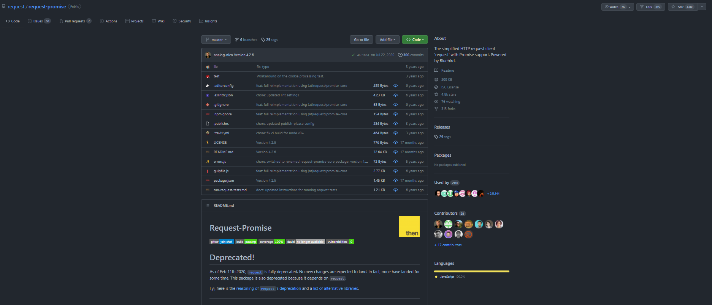

Here => <https://github.com/request/request-promise>

What we need to look for is a way to add those extra parameters throughout the request, and if we look closely enough, we'll see the header options.

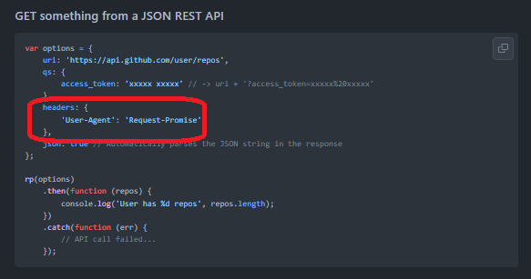

We'll copy the header and paste it into our VS code editor. Right now, we only have the URL as a parameter, and we need to alter it so it's an actual object, so delete the URL and build an object, but we'll still need to input the URI URL and then paste in the headers option.

| const request = require("request-promise"); const cheerio = require("cheerio"); const URL = "https://www.imdb.com/title/tt0068646/?ref_=fn_al_tt_1"; (async () => {  const response = await request({  uri: URL,  headers: {  "User-Agent": "Request-Promise",  },  });  let $ = cheerio.load(response);  // console.log(response);  let title = $("section.ipc-page-section > div > div > h1").text();  let rating = $(  "div.ipc-button__text > div > div:nth-child(2) > div > span"  ).text().slice(0,6);  console.log(`"${title}" movie has a IMDB rating of ${rating}`); })(); |
| --- |

Right now, we have precisely what we had before with the addition of a user parameter to the request with the value request promise. Of course, request promise isn't a user agent, but it's something we can simply adjust based on the documentation provided.

Let's go ahead and obtain the request headers now. Let's go back to the dev tools and look at the first request, making sure it's the one that's responsible for the IMDB page and not an image or a javascript file. Then, just like before, look at the request header and copy everything for now.

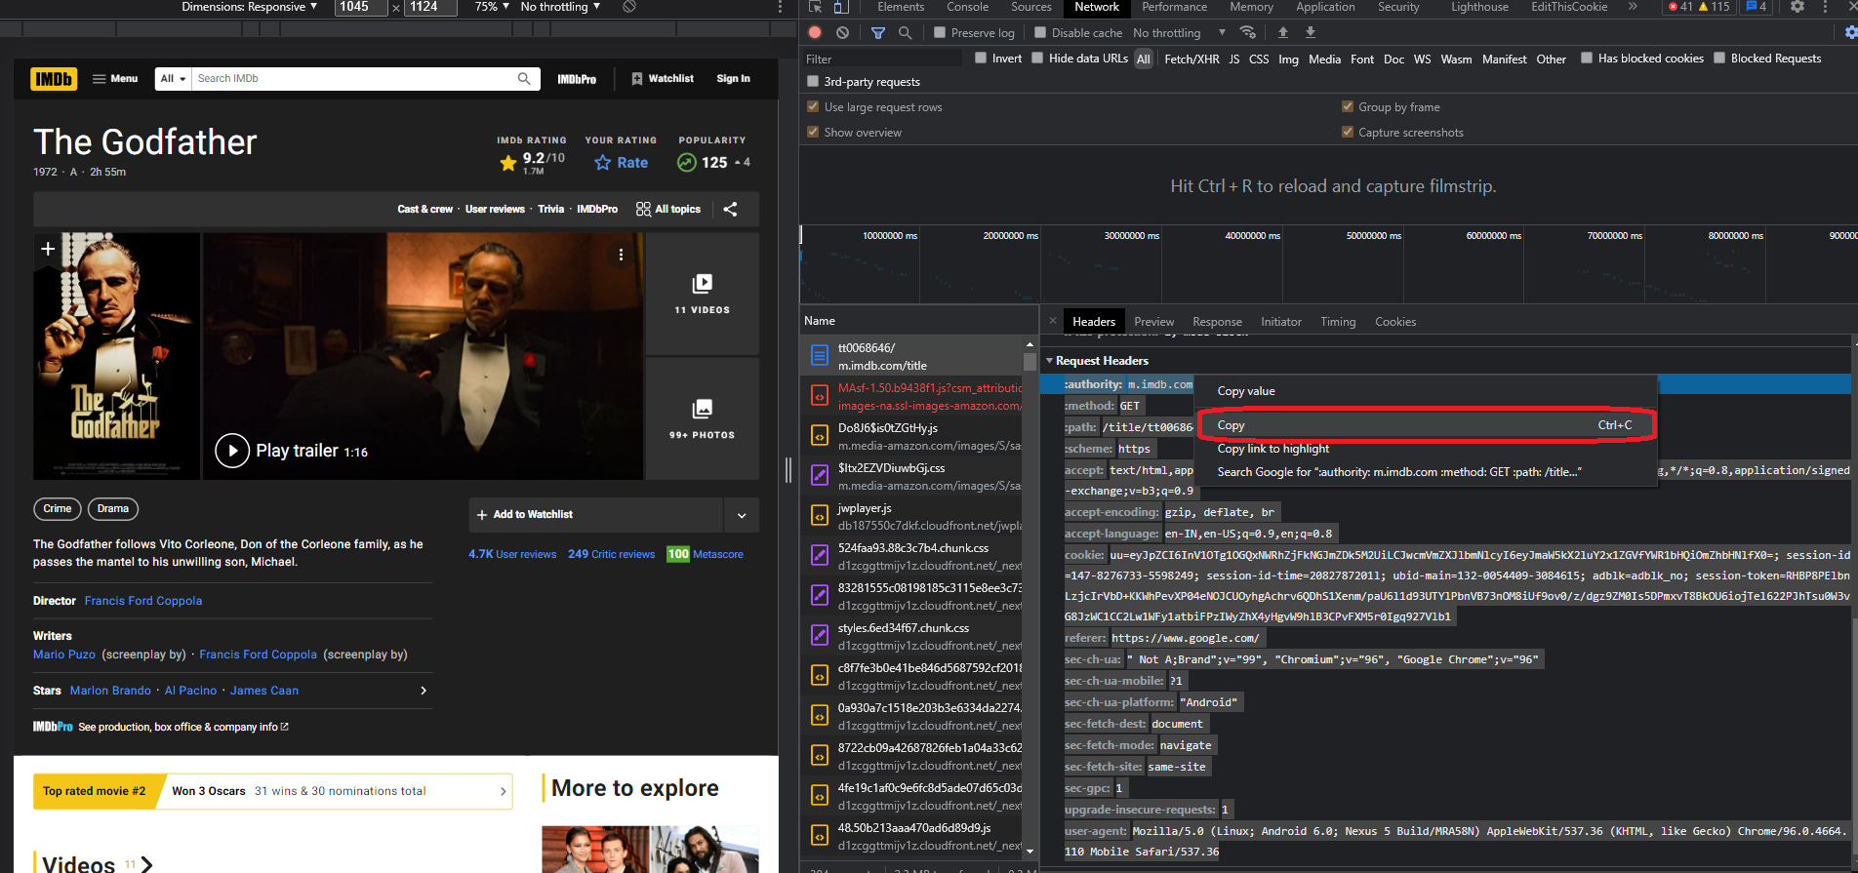

Copy everything and return it to the editor. What we have now are the request headers that are sent by the browser when we enter the IMDB page. What we need to do now is convert them all to javascript objects and pass them on instead of the previous useragent. Let's format them properly and replace them, indent them properly. Now we have control over all of the requests that are sent by the browser are being sent by us. Finally, we only need to worry about the cookie because we don't need it in this situation, so let's erase it, and we're done.

| // index.js const request = require("request-promise"); const cheerio = require("cheerio"); const URL = "https://www.imdb.com/title/tt0068646/?ref_=fn_al_tt_1"; (async () => {  const response = await request({  uri: URL,  headers: {  "accept":  "text/html,application/xhtml+xml,application/xml;q=0.9,image/avif,image/webp,image/apng,*/*;q=0.8,application/signed-exchange;v=b3;q=0.9",  "accept-encoding": "gzip, deflate, br",  "accept-language": "en-IN,en-US;q=0.9,en;q=0.8",  "cache-control": "no-cache",  "pragma": "no-cache",  "sec-ch-ua":  '" Not A;Brand";v="99", "Chromium";v="96", "Google Chrome";v="96"',  "sec-ch-ua-mobile": "?1",  "sec-ch-ua-platform": "Android",  "sec-fetch-dest": "document",  "sec-fetch-mode": "navigate",  "sec-fetch-site": "same-origin",  "sec-fetch-user": "?1",  "sec-gpc": "1",  "upgrade-insecure-requests": "1",  "user-agent":  "Mozilla/5.0 (Linux; Android 6.0; Nexus 5 Build/MRA58N) AppleWebKit/537.36 (KHTML, like Gecko) Chrome/96.0.4664.110 Mobile Safari/537.36",  },  });  let $ = cheerio.load(response);  // console.log(response); let title = $("section.ipc-page-section > div > div > h1").text(); let rating = $(  "div.ipc-button__text > div > div:nth-child(2) > div > span"  ).text().slice(0,6);   console.log(`"${title}" movie has a IMDB rating of ${rating}`); })(); |
| --- |

Now we have the user agent, which is specific to the computer that you're using to code this. You can simply modify this on the user agent and check phoney ones on the internet and paste them right here; you don't need to paste in your actual browser info. Finally, let's put this to the test to see if it still works. Go to the debug tab and select debug play.

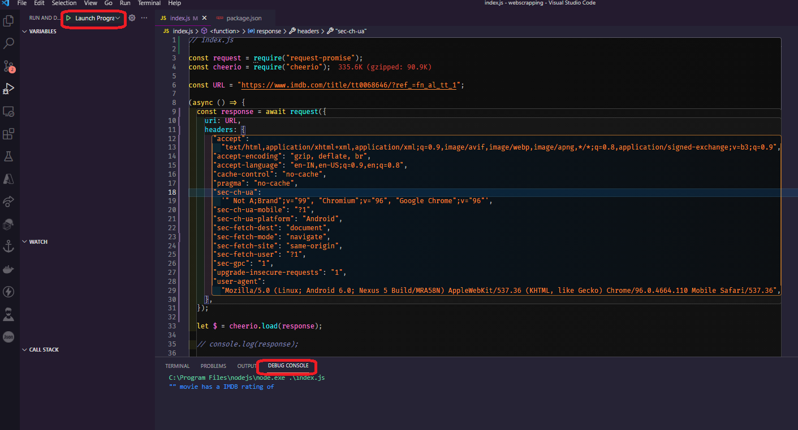

Now, let's hope for the best and head to the debug console, where you can see that it does not work, as it does not print the movie's title or rating. So, we'll use what we learned before and set a debugger right at the console.log line to see what's going on. Let's run it again, and it stops right at the console.log line, and we can see what variables we have. We have the rating, which is an empty string, and the title, which is also an empty string, which means it didn't find the selectors we were looking for because the response changed, as you can see and it is completely nonsensical.

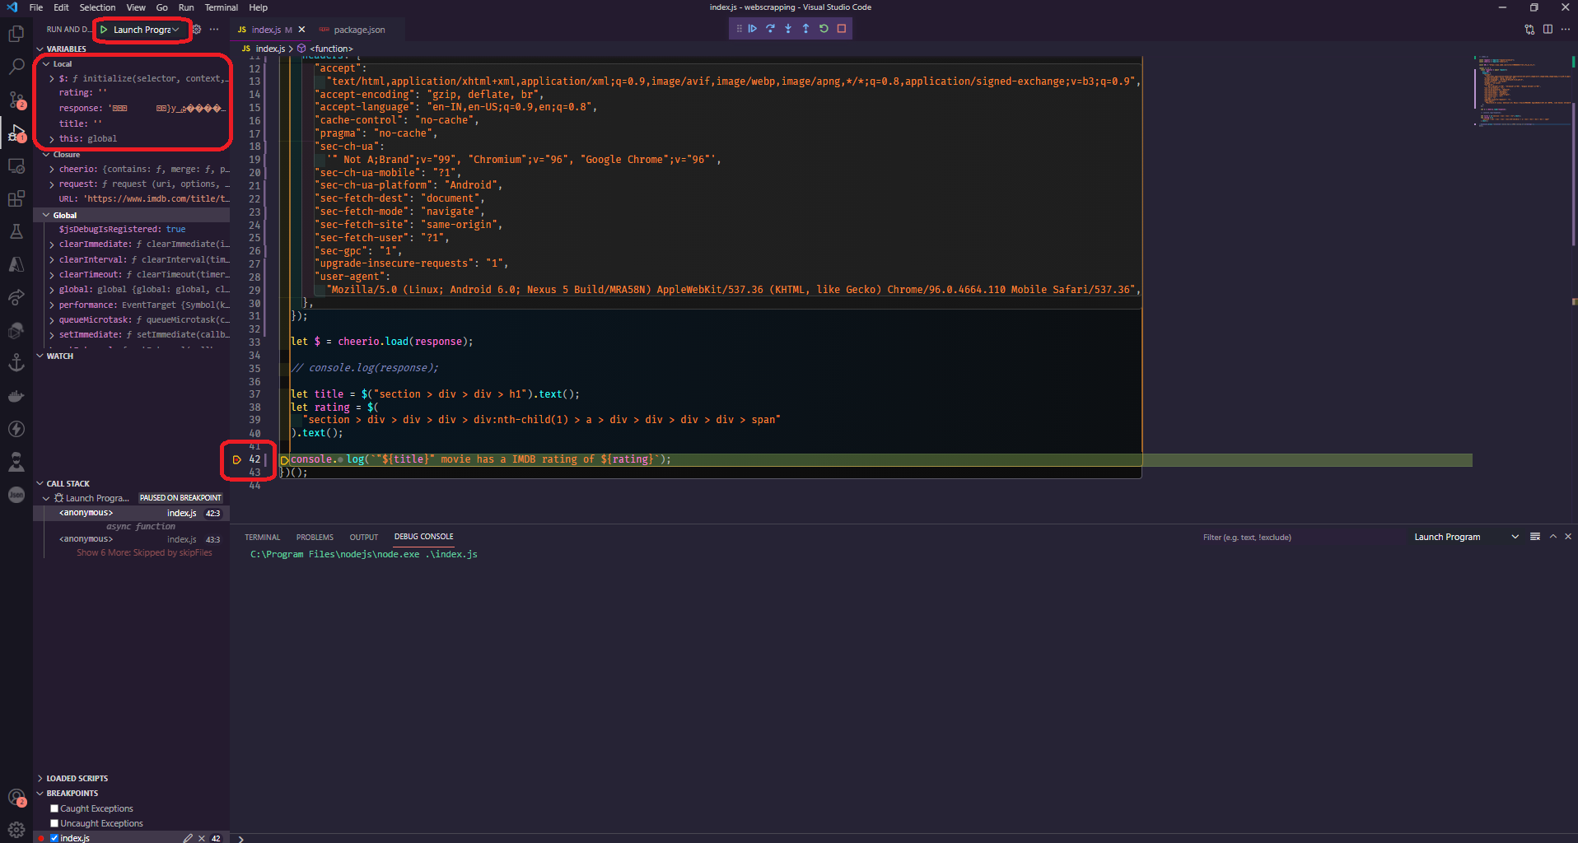

So, when we requested with only the URL, all of the other options were default, but now that we've added our own, everything is the default. We get this response because we forgot to add the gzip option to some of the default parameters for the request function.

**Dealing with websites that have compression encoded in them.**

let's take a closer look at what happened and why it didn't work. This is a frequent mistake that rookie scrapers make when playing with requests; it happens to everyone. You may have also noticed the gibberish encoded response; this is due to the IMDB's usage of the gzip compression algorithm.

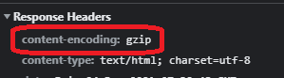

This is done to reduce the size of the response data so that it may be returned faster and save a lot of bandwidth at the same time. Let's get started with this. We can address this by adding an extra parameter to the request function called gzip and setting it to true.

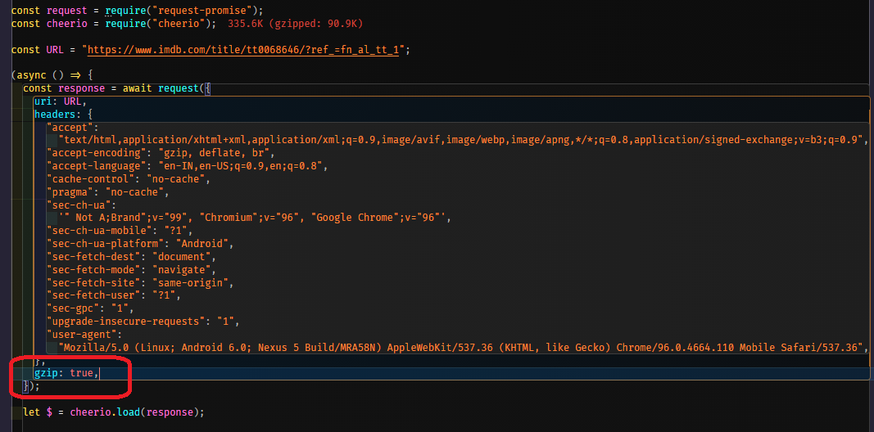

So this will inform the request library to decompress this actual request from IMDB using gzip compression. Let's fast test it out and see if it works, so run your scrapper again.

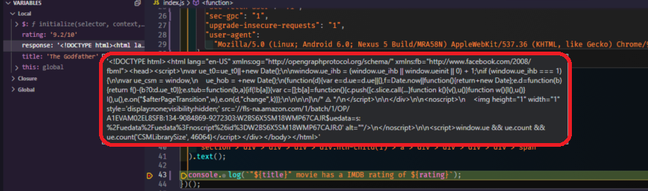

As you can see, we already have a readable <!DOCTYPE> HTML response, as well as everything we had before, and the title and ratings work perfectly.

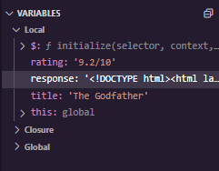

Let's go back to the dev tools, which we already have open, and search for the content encoding on the response headers from the website, which you can see here it states content encoding with the value of gzip, indicating that this website indeed uses gzip compression algorithm.

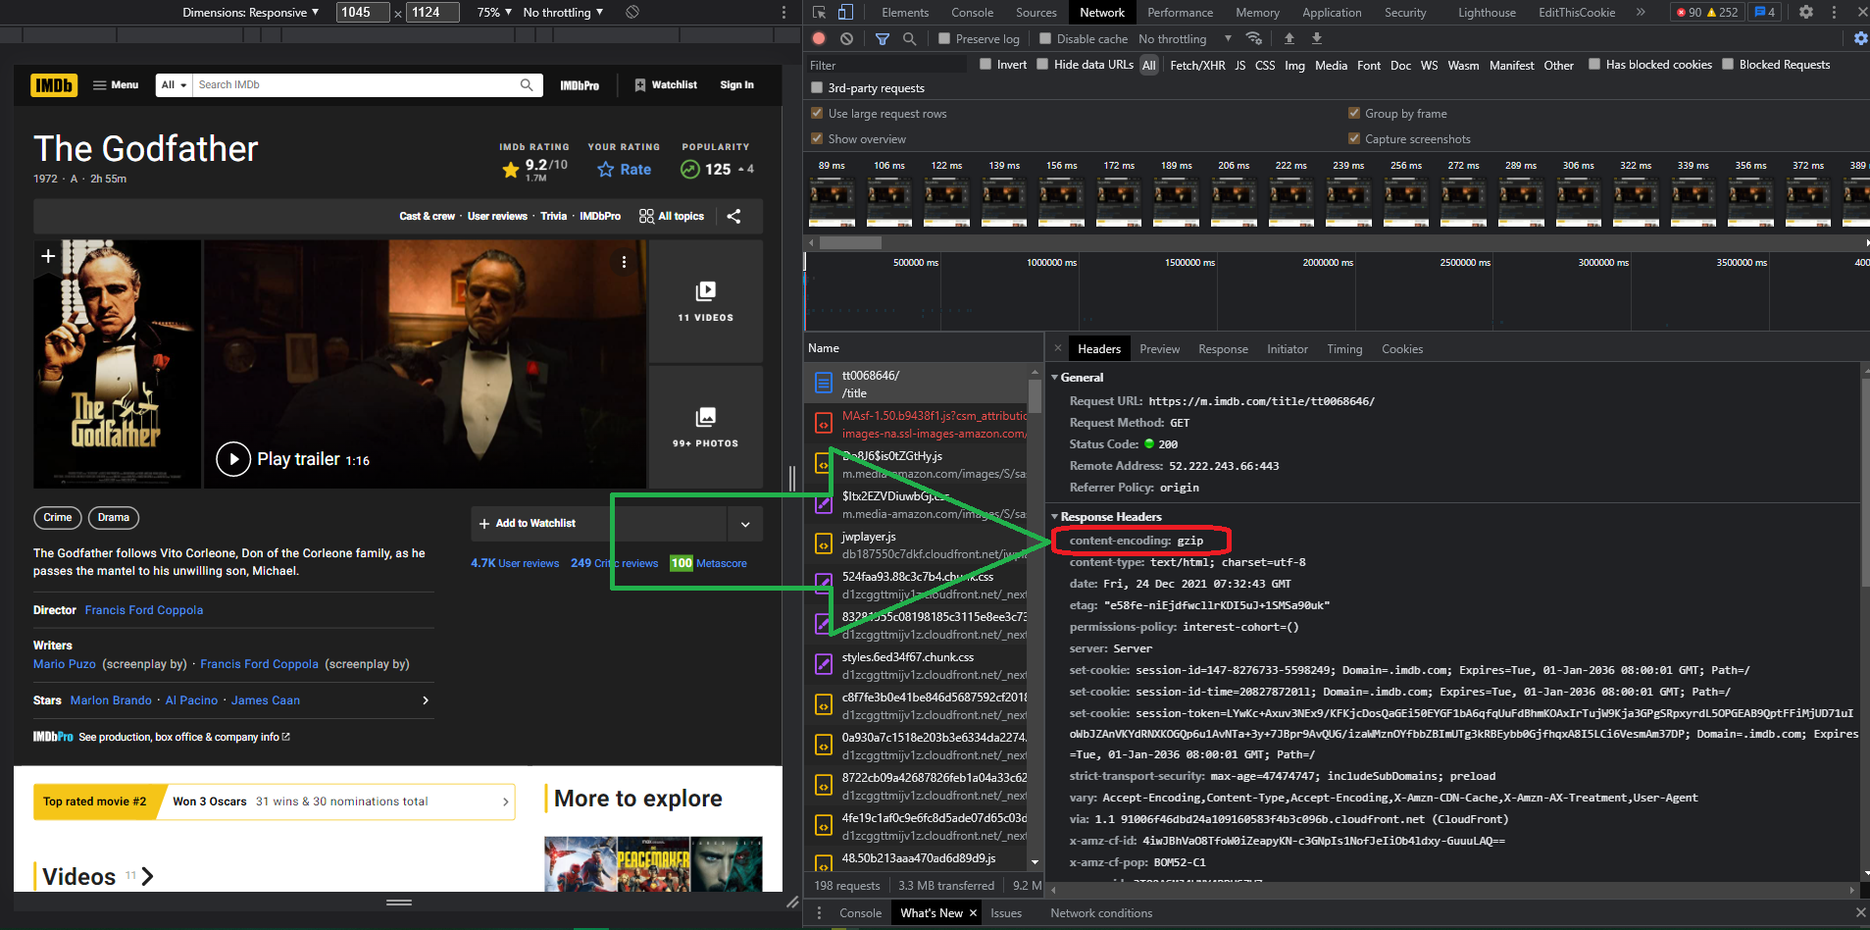

**An in-depth look at jQuery selectors and data parsing**

Let's learn a little more about jquery selectors and where to go for more information about them. It's quite normal and acceptable to not remember all of them. Jquery selectors This is why you should always have the documentation on hand. Let's go to the browser and search for jquery selectors. As you can see, there are a lot of results. Let's go to the [w3 school link](https://www.w3schools.com/jquERy/jquery_ref_selectors.asp). It's not the official one, but it's a very popular website that has all of the selectors that we need. This is what we'll use to search for selectors that we need to scrape some parts of. website.

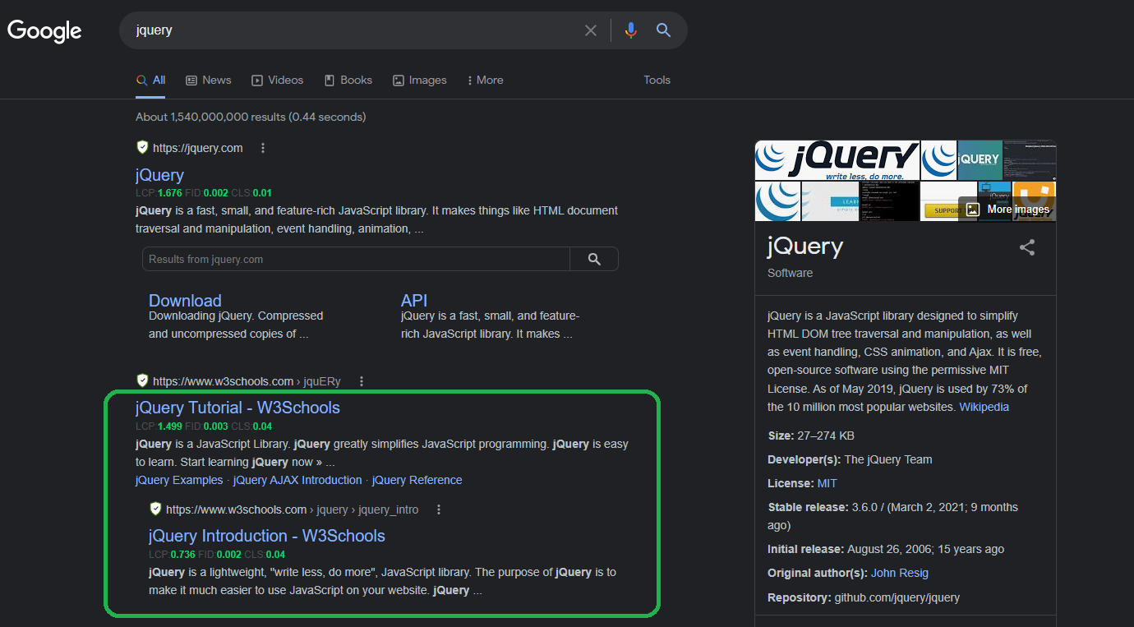

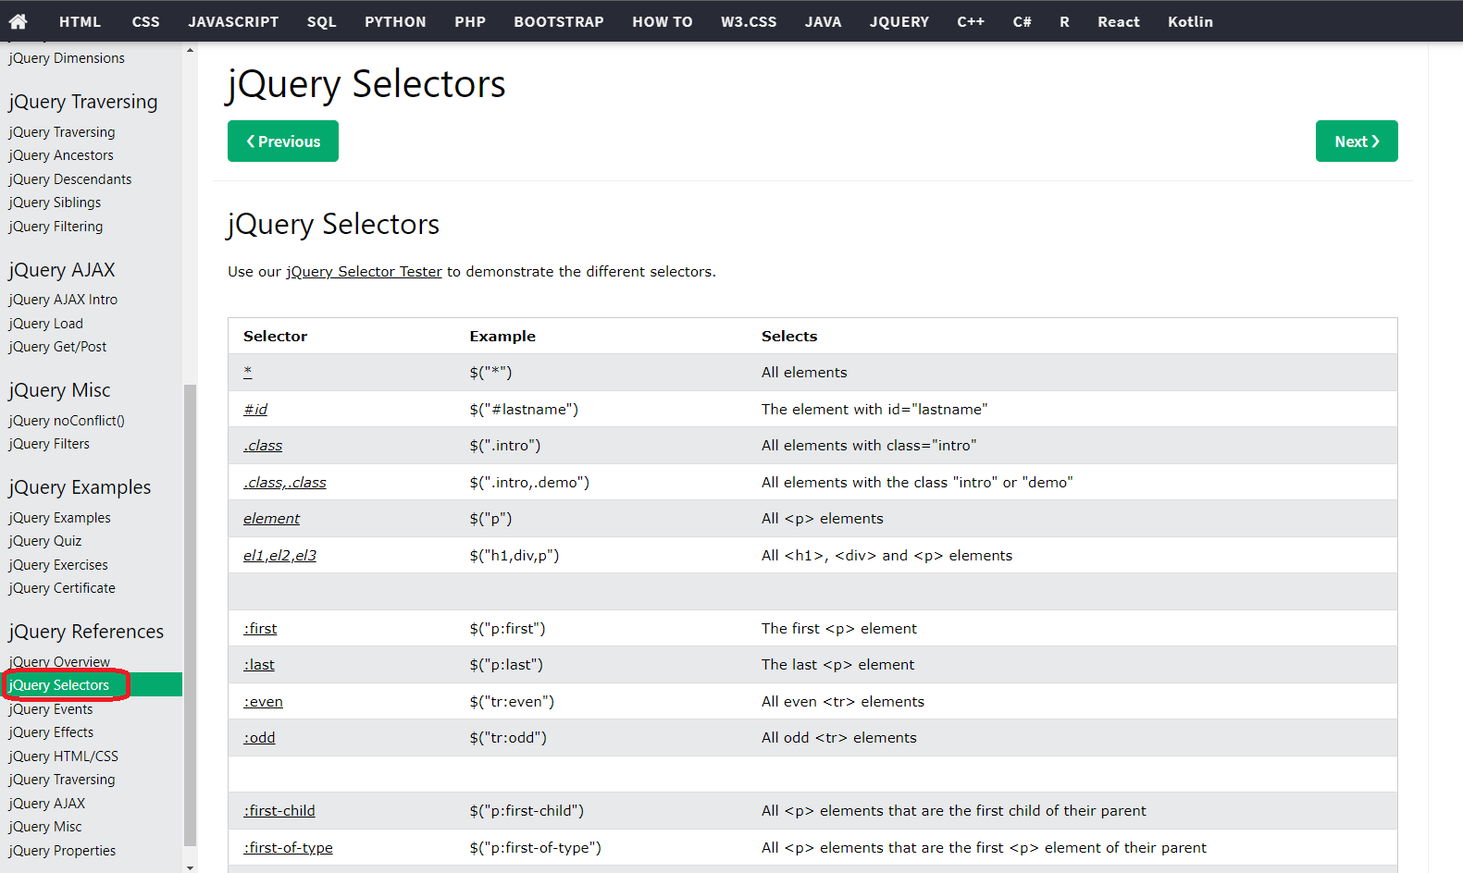

Now, let's get started scraping. Go to IMDB movie page and open the dev tools. Now that we have the movie open, our editor running, and our dev tools open, we can start scraping. There may be some errors, but we'll fix them as we go. By using this method, you'll be able to see the entire thought process behind it, so let's get started.

First, we have the title and the movie rating. Let's assume we want to retrieve the movie poster. To do so, go to the movie poster and check elements, looking for anything unique about it, such as an id or a class name that isn't repeated, or just discover the selector.

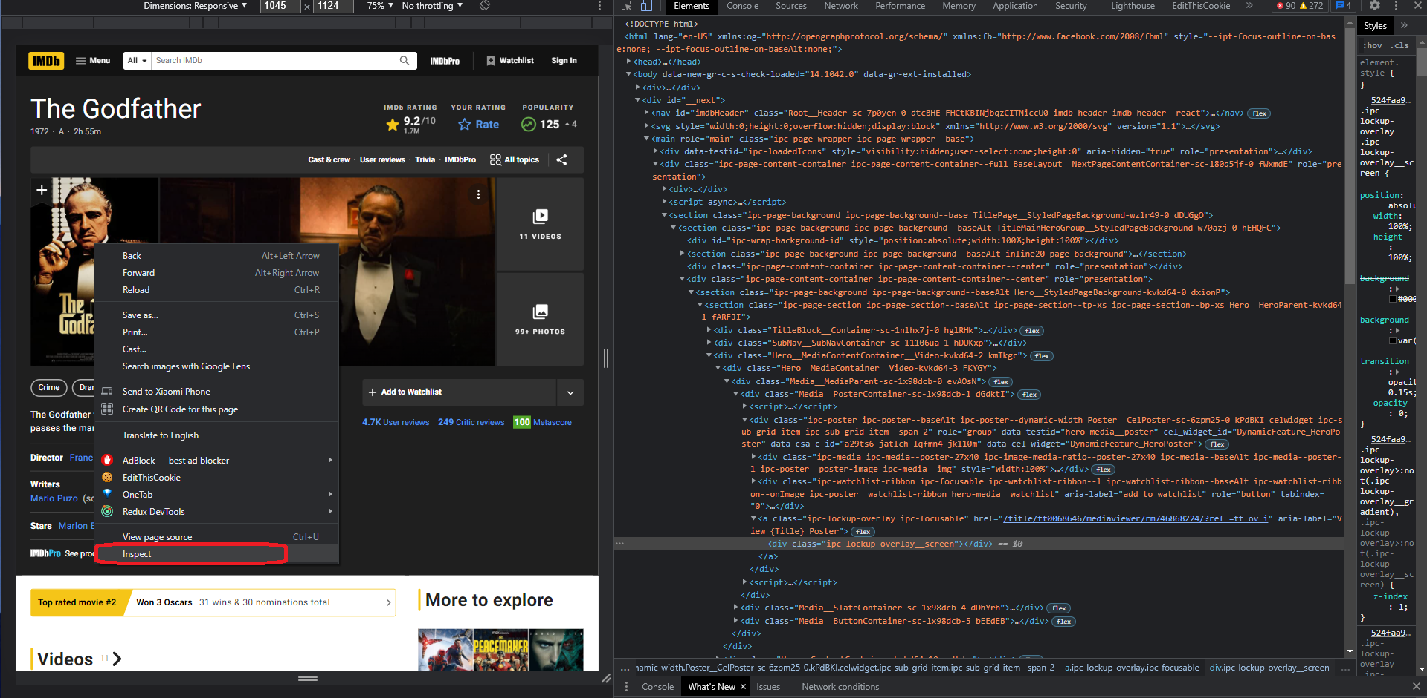

So the first thing that pops up is the div with the class name of ipc-poster, which we can easily get and then access the element and then the image within it. First, let's clear everything in the console, and because this website already has jquery implemented, we can check the jquery code that we're going to write directly in the console. If the website doesn't have jquery implemented, you can inject it and also check it in the console In the later section of this article there is a demo showing how to inject the jquery library inside the browser itself, but just so you know, if you don't see the console tab with the console, you can easily click on escape to toggle between them on and off.

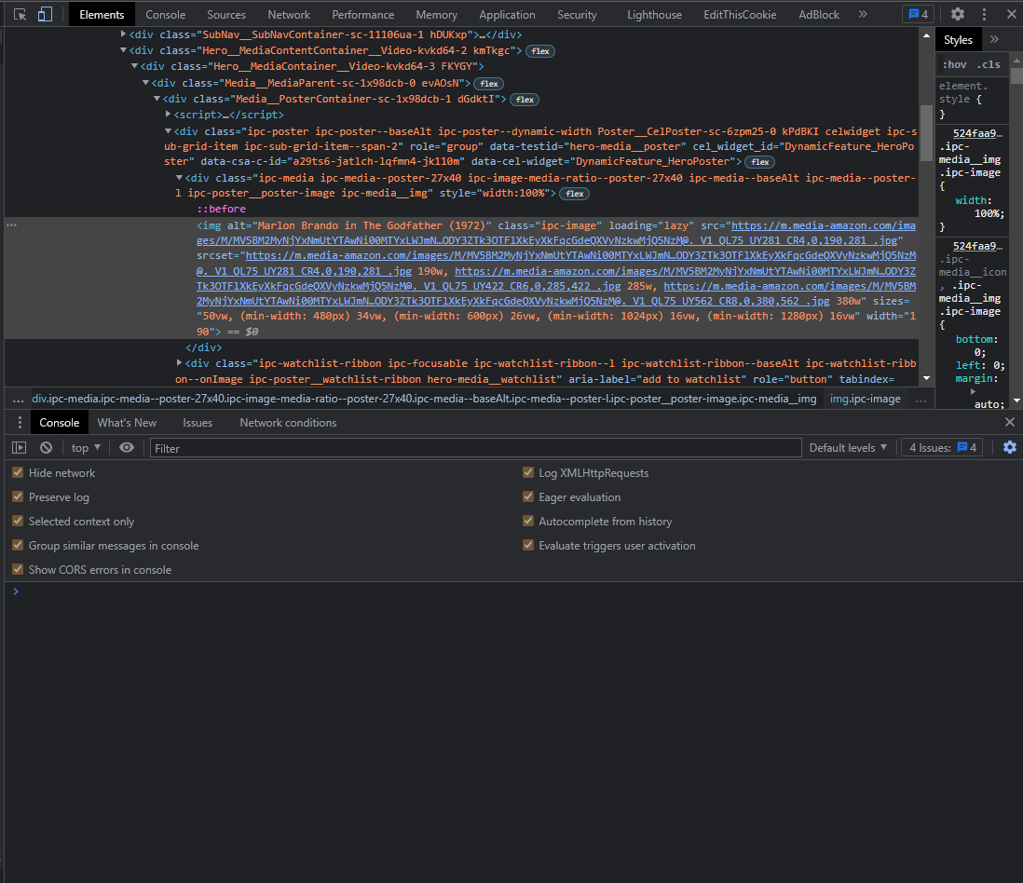

Let's write the code for this image selector. First, we'll select the div with the class name ipc-poster or ipc-media, and then we'll select the child within it, which is an IMG tag, which is the image. We can now expand this element and see that we have an image, so as you can see on the image below it appears that this selector is working perfectly fine.

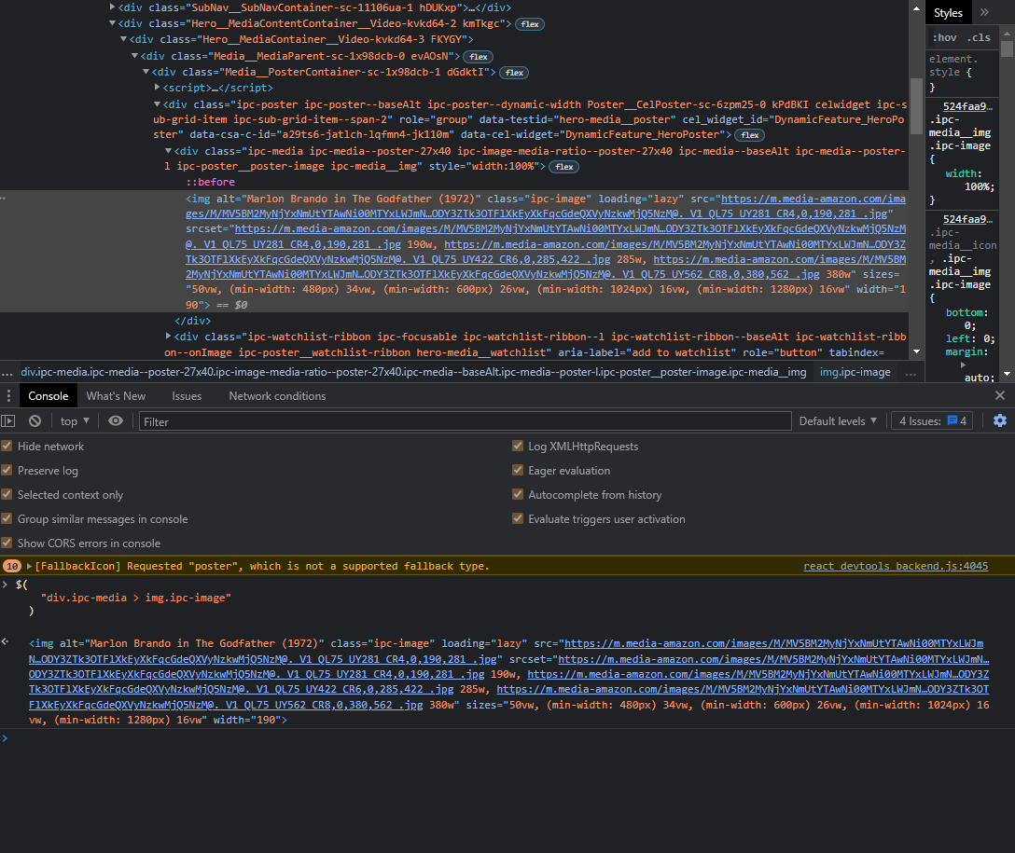

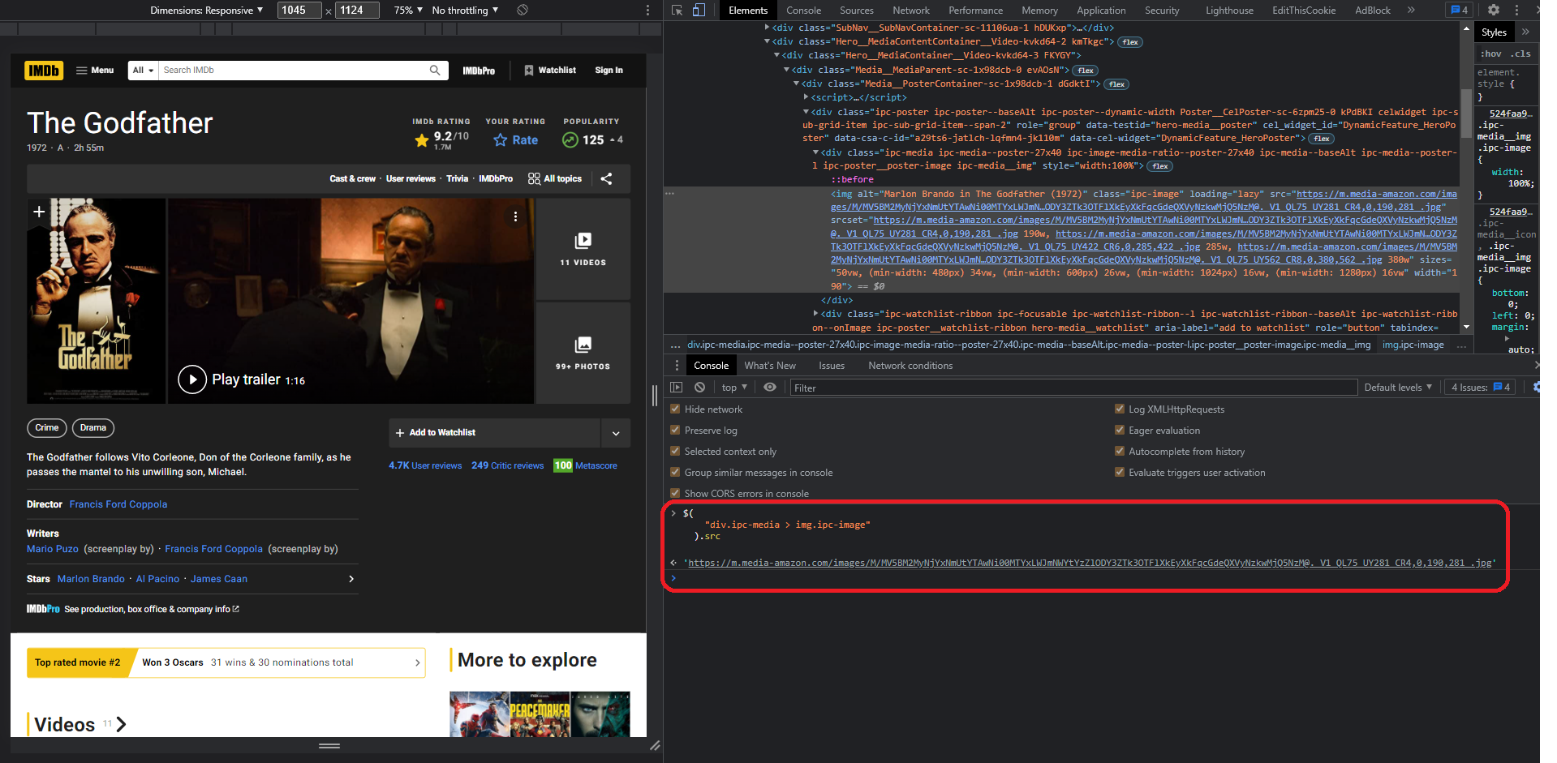

Now that we have a proper and working selector, we need to choose the source of the image to get the actual link of the image, so for that, we can use the attribute function and pass into the parenthesis the exact attribute name that we want to select, in our case, it will be source “src” let's try it out so type attribute and then src enter and it should work.



Finally, let's put this code to the test in our editor by copying the code from the browser console and pasting it into a new variable called imagePoster inside our code editor. This should work the same, so let's console log the imagePoster and remove the breakpoint because we don't need it any longer (you can keep it if you want to check it). So, the code in "index.js" should look like this.

| // index.js const request = require("request-promise"); const cheerio = require("cheerio"); const URL = "https://www.imdb.com/title/tt0068646/?ref_=fn_al_tt_1"; (async () => {  const response = await request({  uri: URL,  headers: {  "accept":  "text/html,application/xhtml+xml,application/xml;q=0.9,image/avif,image/webp,image/apng,*/*;q=0.8,application/signed-exchange;v=b3;q=0.9",  "accept-encoding": "gzip, deflate, br",  "accept-language": "en-IN,en-US;q=0.9,en;q=0.8",  "cache-control": "no-cache",  "pragma": "no-cache",  "sec-ch-ua":  '" Not A;Brand";v="99", "Chromium";v="96", "Google Chrome";v="96"',  "sec-ch-ua-mobile": "?1",  "sec-ch-ua-platform": "Android",  "sec-fetch-dest": "document",  "sec-fetch-mode": "navigate",  "sec-fetch-site": "same-origin",  "sec-fetch-user": "?1",  "sec-gpc": "1",  "upgrade-insecure-requests": "1",  "user-agent":  "Mozilla/5.0 (Linux; Android 6.0; Nexus 5 Build/MRA58N) AppleWebKit/537.36 (KHTML, like Gecko) Chrome/96.0.4664.110 Mobile Safari/537.36",  },  gzip: true,  });  let $ = cheerio.load(response);  // console.log(response);  let title = $("section.ipc-page-section > div > div > h1").text();  let rating = $(  "div.ipc-button__text > div > div:nth-child(2) > div > span"  ).text().slice(0,6); let imagePoster = $("div.ipc-media > img.ipc-image").attr("src");  console.log(  `"${title}" movie has a IMDB rating of ${rating} and the image is ${imagePoster}`  ); })(); |
| --- |

Now go to the debug and start the debugger

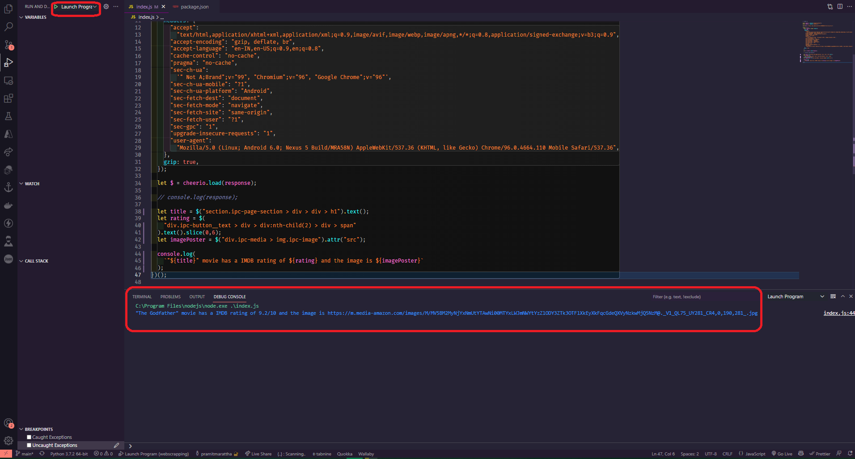

As you can see, the title "The Godfather" has a 9.2 rating, and we also have a link to the image source. Before we go any further, if you have a white space issue in the movie title, you can easily remove it by using the .trim() after the text() method, which will also eliminate the white space between the text.

| let title = $("section.ipc-page-section > div > div > h1").text().trim(); |
| --- |

Let's keep going and proceed to the next step. Okay, so now that we have the title, the poster, and the rating, let's see how much amounts of rating this movie has. Let's right-click on the rating amount and inspect the element first.

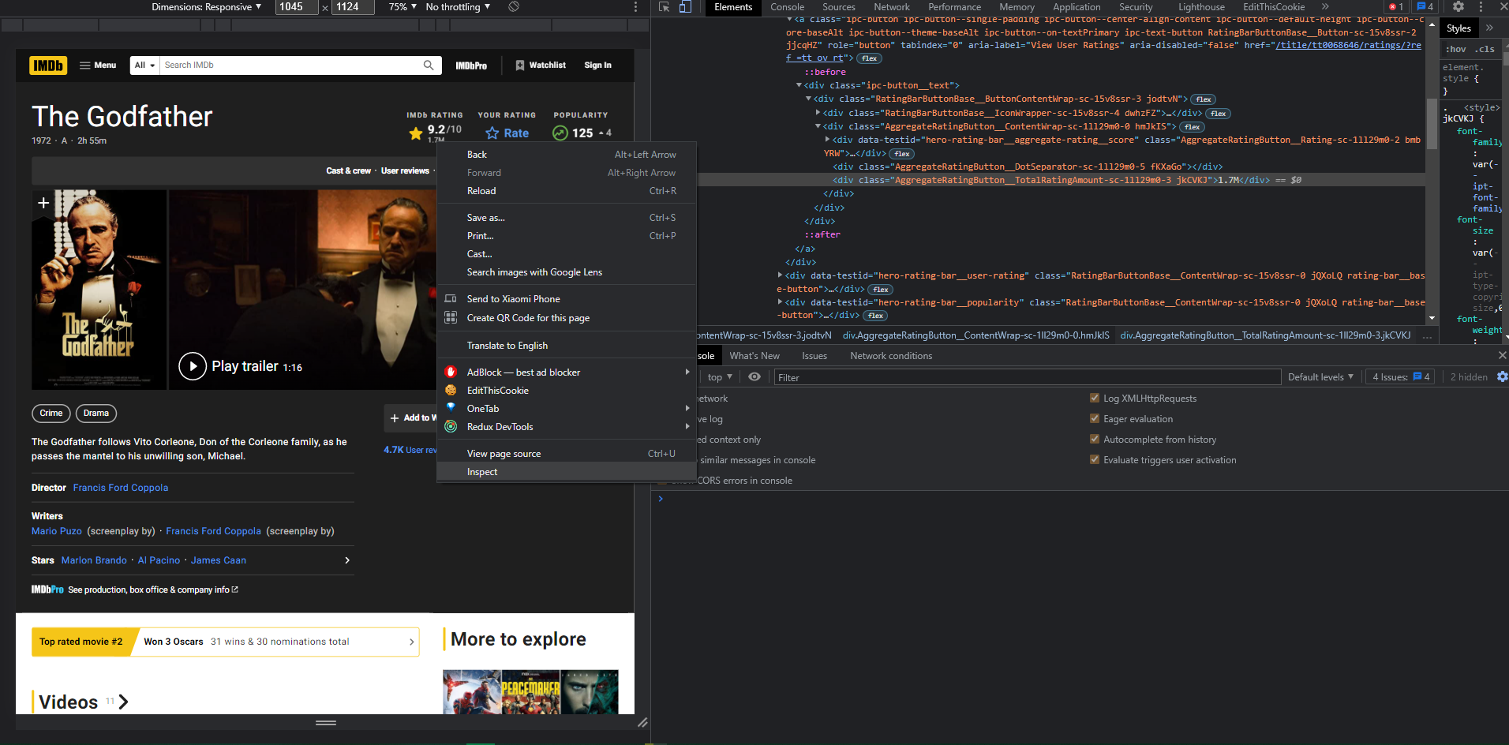

What we can see is that there is a div with another tag of div with the class "AggregateRatingButton__TotalRatingAmount" but nothing useful. We need to go a little higher because we only have the "ipc-button__text" class at the moment. So we can finally check this and grab onto it, acquire the link, and then obtain the text within it. As a result, let's clear the console and start writing code for it.

So first get the div with the class “ipc-button__text, then get the last child, which is another div tag, and finally the last div child, so we can finally obtain the text, and click enter and check if it works.

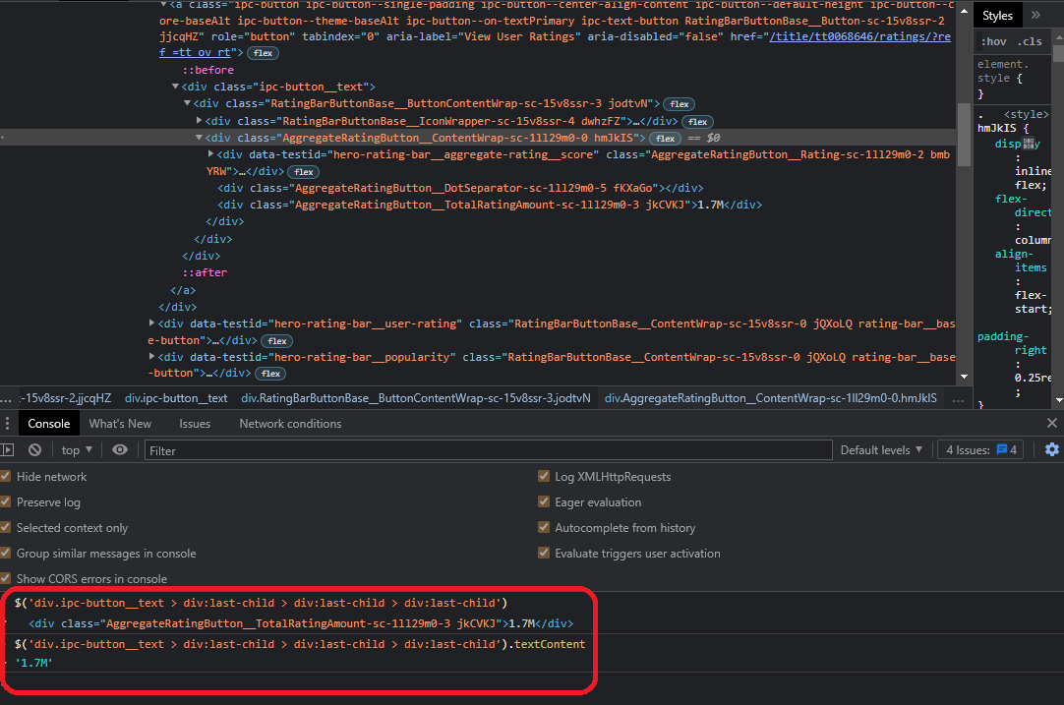

and, as you can see from the image above, it works; as you can see, it displays the precise rating number. Now, let's quickly put this into action, so open the editor and create a new variable called ratingAmount, then paste the following code into it.

| let ratingAmount = $('div.ipc-button__text > div:last-child > div:last-child > div:last-child').text().slice(0,4); |
| --- |

We can immediately test it by logging the ratingAmount in the console and hit play to the debugger.

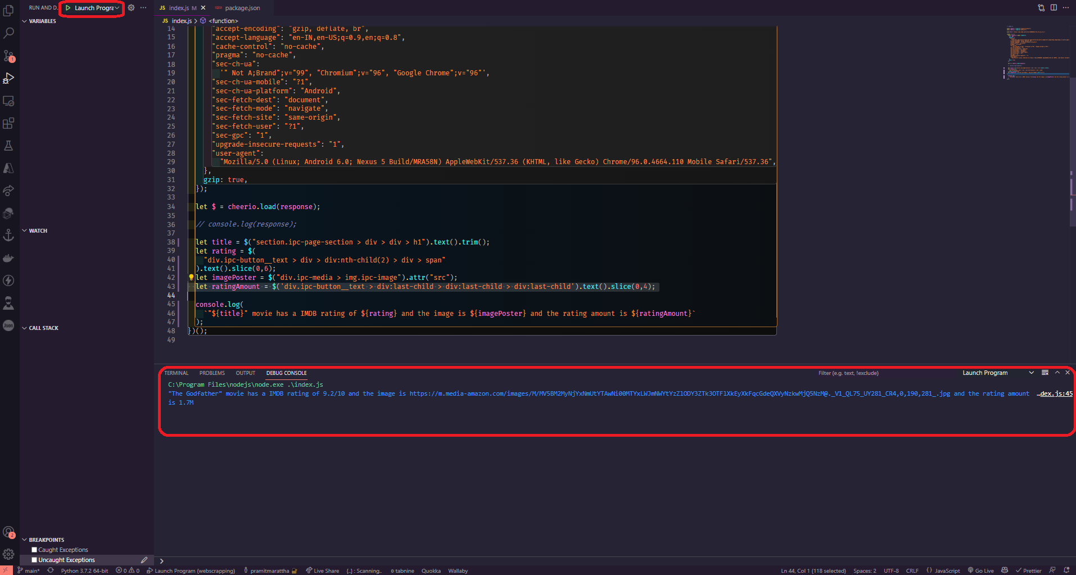

As you can see, it's functioning perfectly, so let's continue and try to get the movie's release year as well. To do so, repeat the previous method and inspect the element once more to see what we have.

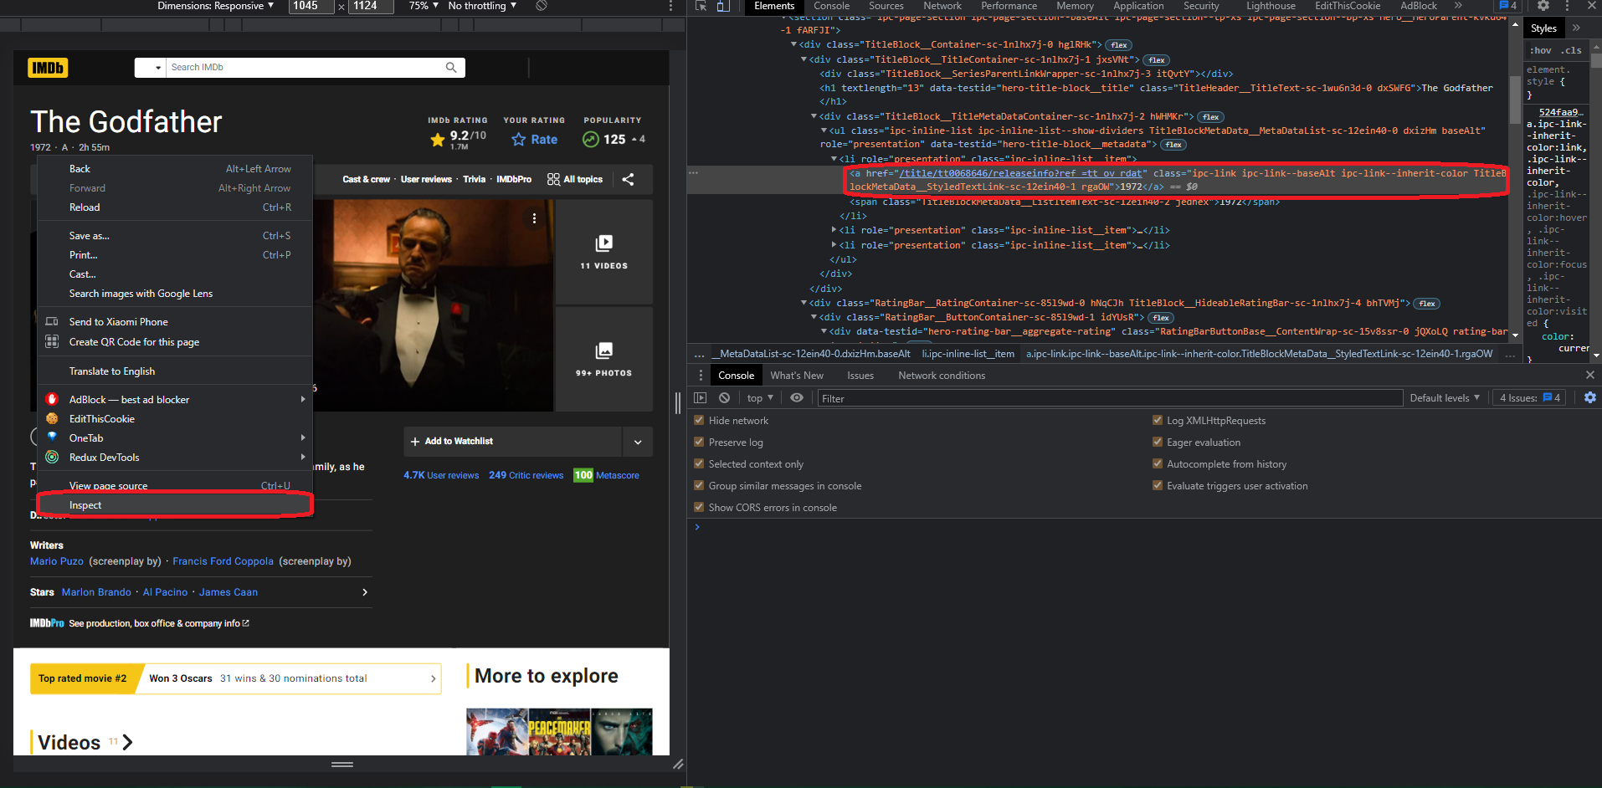

So, there's a list tag with the class “ipc-inline-list__item”, and inside it, we'll select a tag and quickly test it in our console to see whether it's functioning.

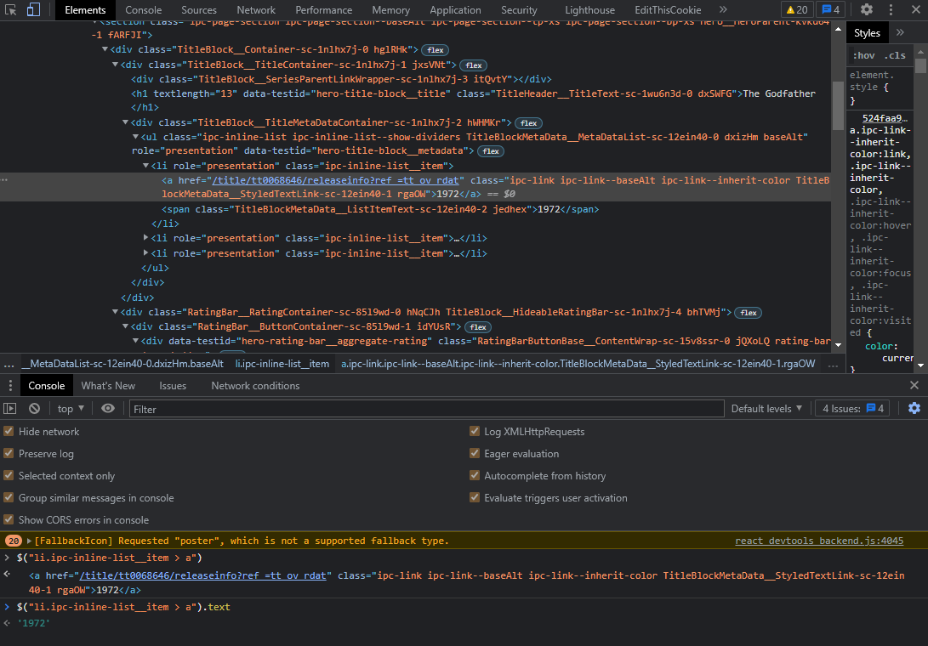

Finally, it works, and we can easily add it to our code editor and use it in our code. Let's copy this and check that it's the text that we want, but in your case, you might see some white space that can be easily removed using the trim function, and we'll also use slice to chuck the exact year only that we need.

So make a variable called releaseYear, paste the code in it, and slice it up.

| let releaseYear = $("li.ipc-inline-list__item > a").text().slice(0,4); |
| --- |

Let's put it to the test right away.

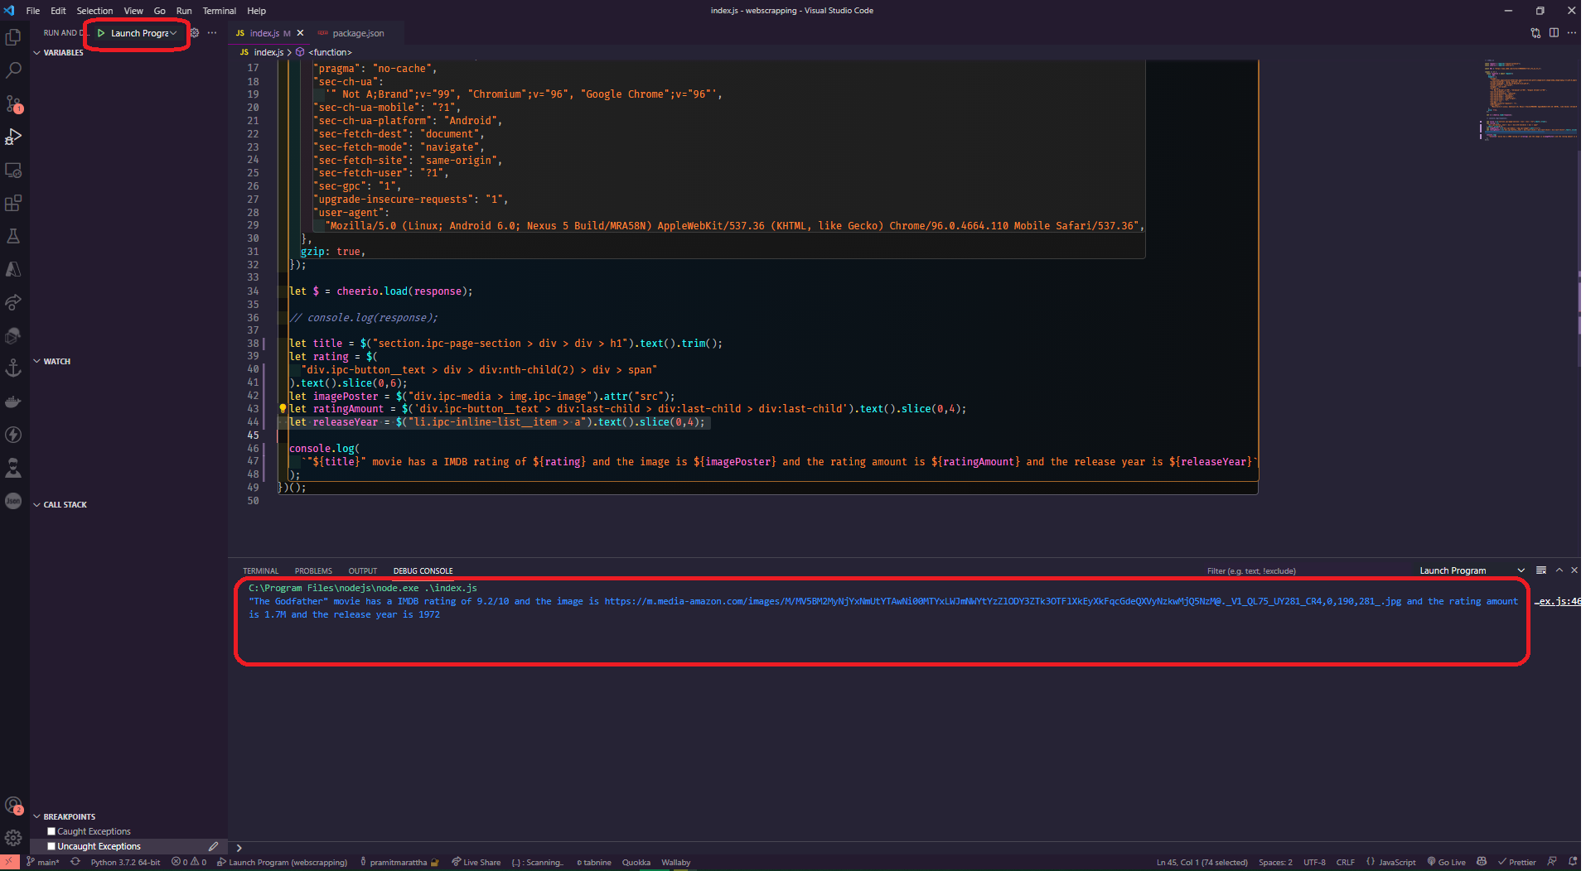

It works perfectly, and we have the title, the rating, the poster, the number of ratings, and the year of release. Now that this is starting to look pretty good, let's attempt something a little more difficult: let's try to get all of the movie's genres in an array rather than as text; we want to have an array with crime and drama.

Again, inspect the element and check it out, as you can see in the image below.

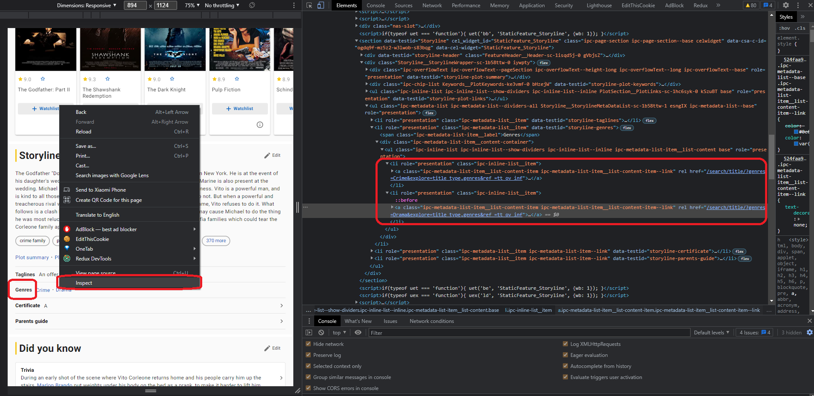

As you can see, all of the links to certain genres, such as crime, have a genre link in common, so this prefix “/search/title/?genres” is present right here in the drama, and we can latch on to it and choose all of the links that have the prefix of the href tag "/search/title/?genres."

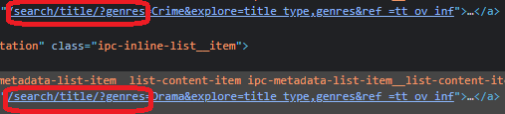

Let's try it out and see if it works; if it does, that's great; if it doesn't, and we're receiving more links than we need then it is because the IMDB page can have numerous links with these types of prefixes.

So first, let's empty off the terminal tab and start writing the code. We want to get all the li tags with "data-testid="storyline-genres" that have a tag with href equal to /search/title/?genres, but we don't want them to start with the prefix genres only but with "/search/title/?genres". So, let's head over to the jquery selectors documentation and look for the starting keyword.

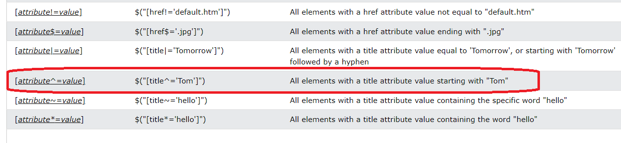

As you can see, we have something right here: all elements with the title attribute value beginning with tom. All we have to do now is add a "^" sign in front of our equal sign, and it will get all the elements that start with the “/search/title/?genres” prefix. Let's add it and then close it and get all the text just for testing purposes.

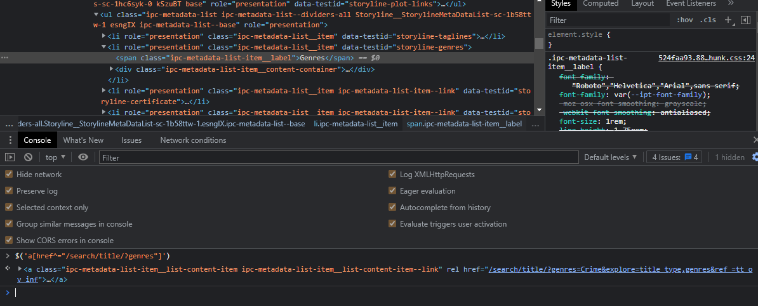

As you can see, it's not displaying the results properly. To fix this, we need to narrow down the search and try to select only the links within a specific parameter, more specifically within these li links. We can easily add this selector so that we can refine our search to get only the links within this parameter. You might be wondering how we do this. First, let's clear the console. Now, right in front of our selector, we need to add the li selector for the data-testid of storyline-genres, and this says that we want to select all the href elements that start with /search/title/?genres that are contained inside this list and let's test it out. Copy and paste the following code into the console.

| $('li[data-testid="storyline-genres"] a[href^="/search/title/?genres"]').text |
| --- |

As you can see, the selector works perfectly, and crime, drama is perfect for the time being. But how do we put this into an array instead of using the text function? We'll use each function, which will iterate through all of the selectors that it finds, and by the way, you can check the documentation for cheerio on GitHub. Let's try it out, but this time instead of text, we'll use each function, which has two parameters: one for the index and the other for the actual element we'll utilize. close it and now that we've done that, we'll make an array called movieGenres and start it as an empty array, and then we'll access the specific element and get their text and insert it into the movieGenres array. We can do this easily by making it like genre equal access the element and then the text inside it, and then we'll just push it to the array movieGenres, and then let's console log movieGenres and yeah it works perfectly, we have an array of crime and drama. This is what your code should look like.

| let moviesGenres = [];  $('li[data-testid="storyline-genres"] a[href^="/search/title/?genres]"').each(  function(i, elm) {  let genre = elm.text;  moviesGenres.push(genre);  }  );  console.log(moviesGenres); |
| --- |

If your code throws an error or doesn't work, you'll need to load jquery into the browser. To do so, open the console and paste the following code.

| var script = document.createElement('script'); script.src = "https://ajax.googleapis.com/ajax/libs/jquery/1.6.3/jquery.min.js"; document.getElementsByTagName('head')[0].appendChild(script); |
| --- |

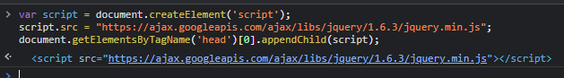

Again, test the previous code in the console; you should see something similar to this.

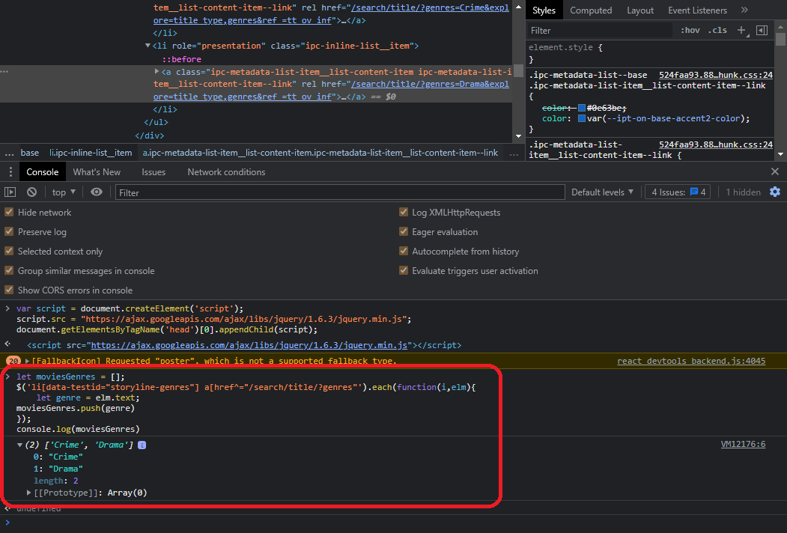

Finally, let's add the code to our scraper and see if it works. Also, copy this code and paste it into the code editor, then console log movieGenres and run it again. As you can see, it works well, and we have an array of crime, drama parsed precisely like in our chrome console.

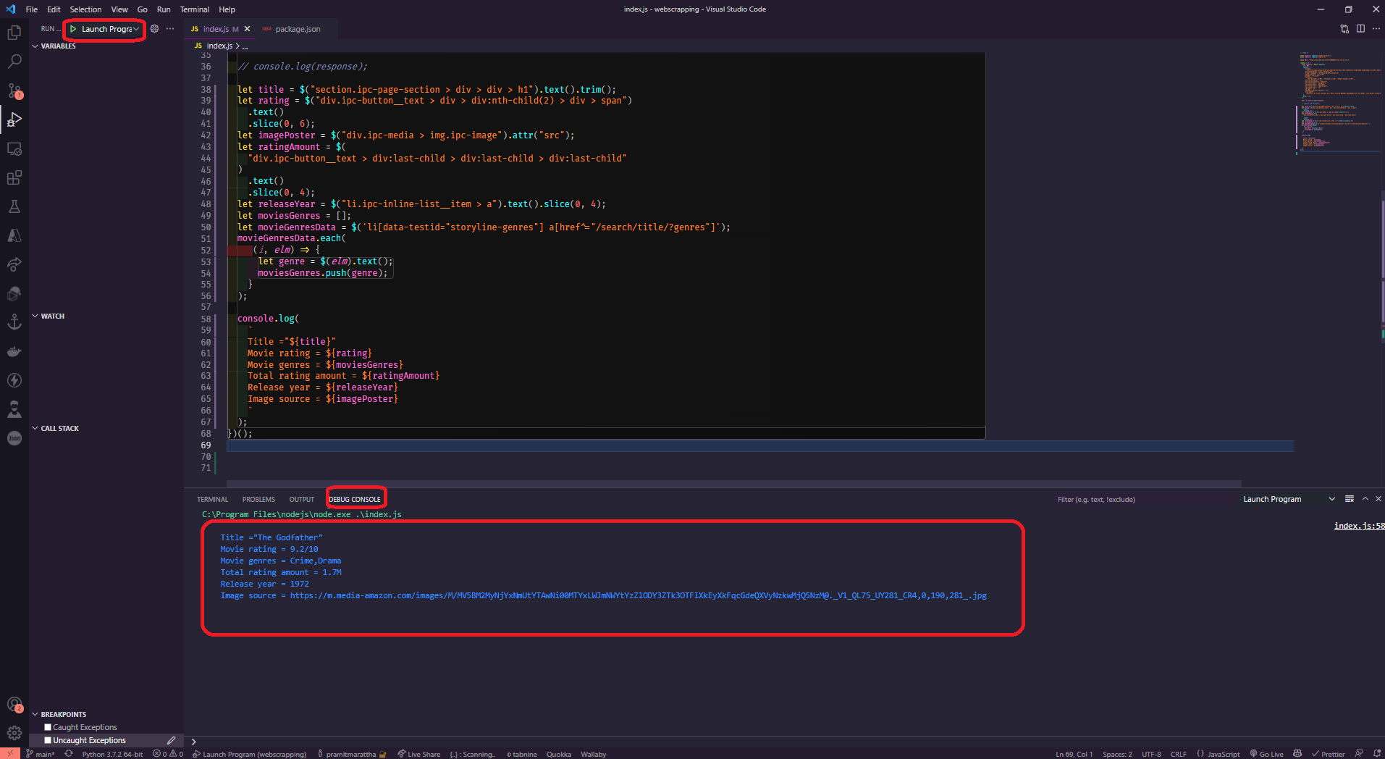

This is what your index.js source code should look like.

| // index.js const request = require("request-promise"); const cheerio = require("cheerio"); const URL = "https://www.imdb.com/title/tt0068646/?ref_=fn_al_tt_1"; (async () => {  const response = await request({  uri: URL,  headers: {  "accept":  "text/html,application/xhtml+xml,application/xml;q=0.9,image/avif,image/webp,image/apng,*/*;q=0.8,application/signed-exchange;v=b3;q=0.9",  "accept-encoding": "gzip, deflate, br",  "accept-language": "en-IN,en-US;q=0.9,en;q=0.8",  "cache-control": "no-cache",  "pragma": "no-cache",  "sec-ch-ua":  '" Not A;Brand";v="99", "Chromium";v="96", "Google Chrome";v="96"',  "sec-ch-ua-mobile": "?1",  "sec-ch-ua-platform": "Android",  "sec-fetch-dest": "document",  "sec-fetch-mode": "navigate",  "sec-fetch-site": "same-origin",  "sec-fetch-user": "?1",  "sec-gpc": "1",  "upgrade-insecure-requests": "1",  "user-agent":  "Mozilla/5.0 (Linux; Android 6.0; Nexus 5 Build/MRA58N) AppleWebKit/537.36 (KHTML, like Gecko) Chrome/96.0.4664.110 Mobile Safari/537.36",  },  gzip: true,  });  let $ = cheerio.load(response);  let title = $("section.ipc-page-section > div > div > h1").text().trim();  let rating = $("div.ipc-button__text > div > div:nth-child(2) > div > span")  .text()  .slice(0, 6);  let imagePoster = $("div.ipc-media > img.ipc-image").attr("src");  let ratingAmount = $(  "div.ipc-button__text > div:last-child > div:last-child > div:last-child"  )  .text()  .slice(0, 4);  let releaseYear = $("li.ipc-inline-list__item > a").text().slice(0, 4);  let moviesGenres = [];  let movieGenresData = $('li[data-testid="storyline-genres"] a[href^="/search/title/?genres"]');  movieGenresData.each(  (i, elm) => {  let genre = $(elm).text();  moviesGenres.push(genre);  }  );  console.log(  `  Title ="${title}"  Movie rating = ${rating}  Movie genres = ${moviesGenres}  Total rating amount = ${ratingAmount}  Release year = ${releaseYear}  Image source = ${imagePoster}  `  ); })(); |
| --- |

**Scraping multiple movies and saving JSON to a file**

In this section, we'll rapidly learn a new way for scraping several movies from an array of given URLs and saving the data we collect as JSON in a file, so let's get started. The first thing you'll want to do is turn the constant into an array.



So now we have multiple URLs, let's open another movie link on the IMDB website, copy the URL, convert it to an array, and input another movie, and that's all there is to it.

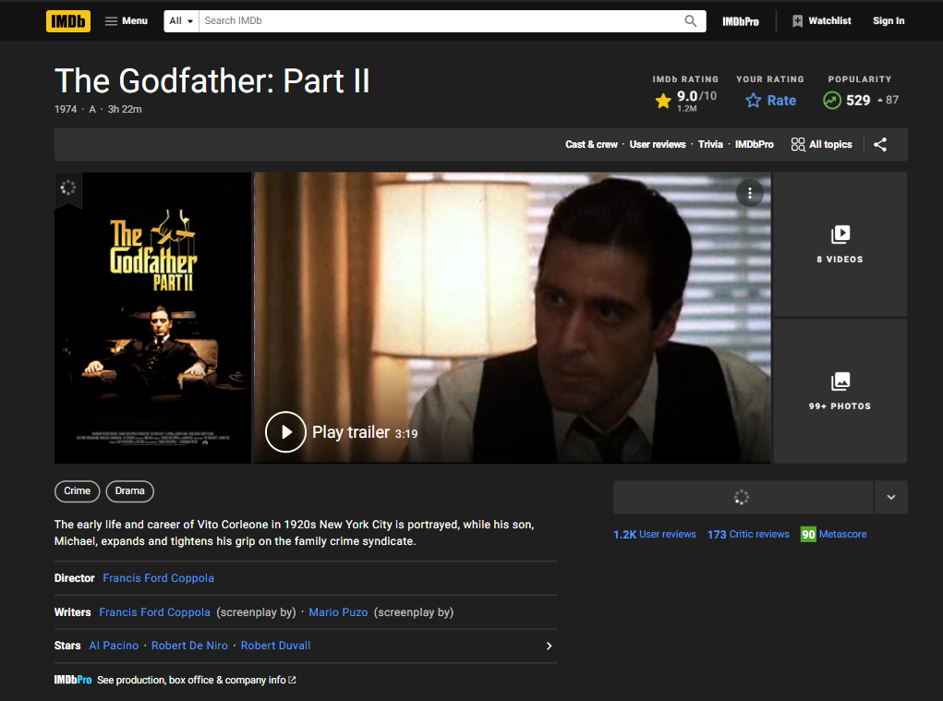

| const URLS = ["https://www.imdb.com/title/tt0068646/?ref_=fn_al_tt_1","https://m.imdb.com/title/tt0071562/?ref_=tt_sims_tt_t_1"]; |
| --- |

So, right now, we have two movies that we want to scrape for information. To do so, simply go inside the defined asynchronous function and follow/paste the code as shown below.

| // index.js const request = require("request-promise"); const cheerio = require("cheerio"); const URLS = ["https://www.imdb.com/title/tt0068646/?ref_=fn_al_tt_1","https://m.imdb.com/title/tt0071562/?ref_=tt_sims_tt_t_1"];  (async () => {   for (let url of URLS) {  const response = await request({  uri: url,  headers: {  "accept":  "text/html,application/xhtml+xml,application/xml;q=0.9,image/avif,image/webp,image/apng,*/*;q=0.8,application/signed-exchange;v=b3;q=0.9",  "accept-encoding": "gzip, deflate, br",  "accept-language": "en-IN,en-US;q=0.9,en;q=0.8",  "cache-control": "no-cache",  "pragma": "no-cache",  "sec-ch-ua":  '" Not A;Brand";v="99", "Chromium";v="96", "Google Chrome";v="96"',  "sec-ch-ua-mobile": "?1",  "sec-ch-ua-platform": "Android",  "sec-fetch-dest": "document",  "sec-fetch-mode": "navigate",  "sec-fetch-site": "same-origin",  "sec-fetch-user": "?1",  "sec-gpc": "1",  "upgrade-insecure-requests": "1",  "user-agent":  "Mozilla/5.0 (Linux; Android 6.0; Nexus 5 Build/MRA58N) AppleWebKit/537.36 (KHTML, like Gecko) Chrome/96.0.4664.110 Mobile Safari/537.36",  },  gzip: true,  });  let $ = cheerio.load(response);  let title = $("section.ipc-page-section > div > div > h1").text().trim();  let rating = $("div.ipc-button__text > div > div:nth-child(2) > div > span")  .text()  .slice(0, 6);  let imagePoster = $("div.ipc-media > img.ipc-image").attr("src");  let ratingAmount = $(  "div.ipc-button__text > div:last-child > div:last-child > div:last-child"  )  .text()  .slice(0, 4);  let releaseYear = $("li.ipc-inline-list__item > a").text().slice(0, 4);  let moviesGenres = [];  let movieGenresData = $('li[data-testid="storyline-genres"] a[href^="/search/title/?genres"]');  movieGenresData.each(  (i, elm) => {  let genre = $(elm).text();  moviesGenres.push(genre);  });  console.log(  `  Title ="${title}"  Movie rating = ${rating}  Movie genres = ${moviesGenres}  Total rating amount = ${ratingAmount}  Release year = ${releaseYear}  Image source = ${imagePoster}  `  );  } })(); |
| --- |

This loop will iterate over each of the URLs that we created previously. Now that the movie's URL is going to be URLs instead of URL, we need to alter the URI and assign URLs, and of course, this should work. We should give it a try right now and see what we have.

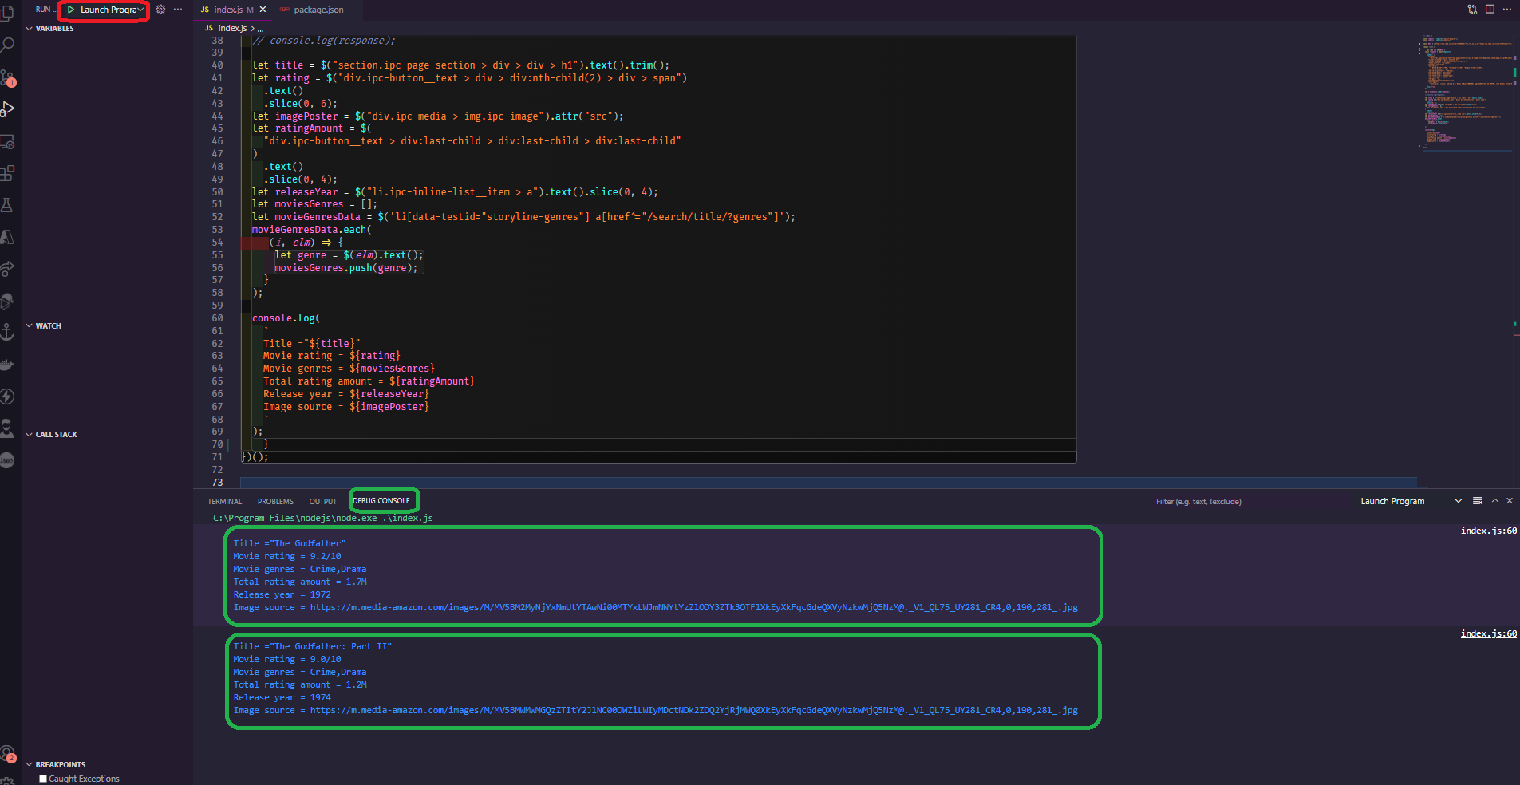

As you can see, the first request is made, and it outputs "The Godfather," the rating, and everything else we've got, and then it waits for the rest of the request to finish, and then it makes the second request to "The Godfather Part 2" movie, and it outputs it to the console, so everything is working as it should. Let's prepare the data and save it as JSON into another variable. Let's start by defining moviesParseData as an empty array, then push in that array exactly before the console log, so that we have an array with all of the scraped movie results. We're using moviesParseData to add another entry to this array, and we want it to be an object. So, let's push the title, the rating, the poster, the number of ratings, the year of release, and, of course, the genres. As a side note, this is a shorthand strategy, but for the time being, let's keep it simple because it looks cleaner.

| let moviesParseData = [];  ...  ...  ...  moviesParseData.push({  title,  rating,  imagePoster,  ratingAmount,  releaseYear,  moviesGenres,  }) |
| --- |

Okay, now let's test what we did. We should anticipate this array to be populated with all of the details of both movies. Let's comment out all of the console log and then console log "moviesParseData" to access all of the movies. We need to put a breakpoint in that console log so that the debugger stops right at that console log. so now, let's test it out and it does indeed stops right at the breakpoint line all right then let's take a look at the console so we have an array hence expand the array and then we have the length of two objects exactly what we expected as you can see the title "The Godfather" and "The Godfather part 2" and its rating, poster, and everything else.

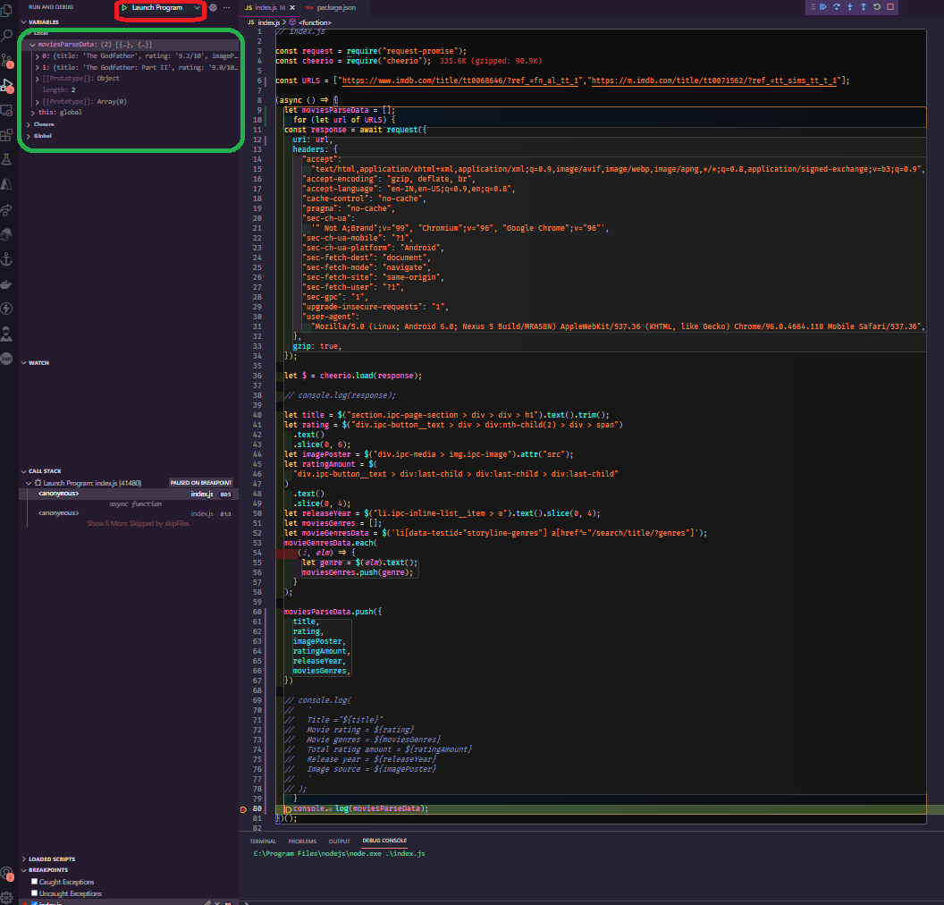

Right now, we have two movies that we scraped, and we'll continue by saving this data to a file. First, let's close the debugger, and to save files to the system, we'll use a native library from node.js called fs( file system). Currently, what we want to do is import the library, which we can easily do without having to install anything because it's already implemented inside the node.js itself.

| const fs = require("fs"); |
| --- |

Now that we've got the library and the movie's data in an array, we can create the method to save it to a file with ease. We're going to use the writeFileSync fs method. Three parameters are required by this function. The first is the actual path to the file that you want to write, the second is the content, and the third is the type of information that you want to save the actual encoding. Let’s save it as "movies.json" and the content inside it to be the moviesParseData in actual string form, so we'll use JSON stringify and pass in the moviesParseData array. This will transform the array into an actual JSON string and finally, we are going to save it in utf-8 encoding/format.

| fs.writeFileSync("movies.json", JSON.stringify(moviesParseData), "utf-8"); |
| --- |

Before we start testing this, let's look at why we used the writeFileSync function. We're using this function with the sync after it because it tells node.js that we want to wait for this line to finish before moving on to the next one, which is similar to writing await in front of it but it doesn't work like this because the fs writeFile function doesn't return a promise, so await and async only work with promises.

The next step is to start/run the debugger, and we should expect it to produce a "movies.json" file in our directory. So check it out, and everything is just as we expected it to be. We have the "movies.json" file, and all of the JSON material is placed in this file.

This is what your final code should look like.

| // index.js const request = require("request-promise"); const cheerio = require("cheerio"); const fs = require("fs");  const URLS = ["https://www.imdb.com/title/tt0068646/?ref_=fn_al_tt_1","https://m.imdb.com/title/tt0071562/?ref_=tt_sims_tt_t_1"];  (async () => {  let moviesParseData = [];  for (let url of URLS) {  const response = await request({  uri: url,  headers: {  "accept":  "text/html,application/xhtml+xml,application/xml;q=0.9,image/avif,image/webp,image/apng,*/*;q=0.8,application/signed-exchange;v=b3;q=0.9",  "accept-encoding": "gzip, deflate, br",  "accept-language": "en-IN,en-US;q=0.9,en;q=0.8",  "cache-control": "no-cache",  "pragma": "no-cache",  "sec-ch-ua":  '" Not A;Brand";v="99", "Chromium";v="96", "Google Chrome";v="96"',  "sec-ch-ua-mobile": "?1",  "sec-ch-ua-platform": "Android",  "sec-fetch-dest": "document",  "sec-fetch-mode": "navigate",  "sec-fetch-site": "same-origin",  "sec-fetch-user": "?1",  "sec-gpc": "1",  "upgrade-insecure-requests": "1",  "user-agent":  "Mozilla/5.0 (Linux; Android 6.0; Nexus 5 Build/MRA58N) AppleWebKit/537.36 (KHTML, like Gecko) Chrome/96.0.4664.110 Mobile Safari/537.36",  },  gzip: true,  });   let $ = cheerio.load(response);   // console.log(response);   let title = $("section.ipc-page-section > div > div > h1").text().trim();  let rating = $("div.ipc-button__text > div > div:nth-child(2) > div > span")  .text()  .slice(0, 6);  let imagePoster = $("div.ipc-media > img.ipc-image").attr("src");  let ratingAmount = $(  "div.ipc-button__text > div:last-child > div:last-child > div:last-child"  )  .text()  .slice(0, 4);  let releaseYear = $("li.ipc-inline-list__item > a").text().slice(0, 4);  let moviesGenres = [];  let movieGenresData = $('li[data-testid="storyline-genres"] a[href^="/search/title/?genres"]');  movieGenresData.each(  (i, elm) => {  let genre = $(elm).text();  moviesGenres.push(genre);  }  );   moviesParseData.push({  title,  rating,  imagePoster,  ratingAmount,  releaseYear,  moviesGenres,  })  // console.log(  // `  // Title ="${title}"  // Movie rating = ${rating}  // Movie genres = ${moviesGenres}  // Total rating amount = ${ratingAmount}  // Release year = ${releaseYear}  // Image source = ${imagePoster}  // `  // );  }  fs.writeFileSync("movies.json", JSON.stringify(moviesParseData), "utf-8");  console.log(moviesParseData); })(); |
| --- |

**Exporting scraped data to CSV file.**

Let's first learn how to export the scraped data to a CSV file if you're working with them and need to use them in any way. A CSV file is a comma-separated value file in which the first line represents the keys and the subsequent lines represent the rows with the values for those specific keys, with each value separated by a comma. While creating a CSV file is not a difficult task, it is preferable to use a well-maintained library that does the job with two or three lines of code rather than writing and maintaining your own.

So you can easily develop a CSV generator, but if you want to get things done quickly and easily, which is what most people want, you should use something like json2csv, which is a npm package that you can use straight with node. So go to json2csv and then to its [npm](https://www.npmjs.com/package/json2csv) and [github repository](https://mircozeiss.com/json2csv/).

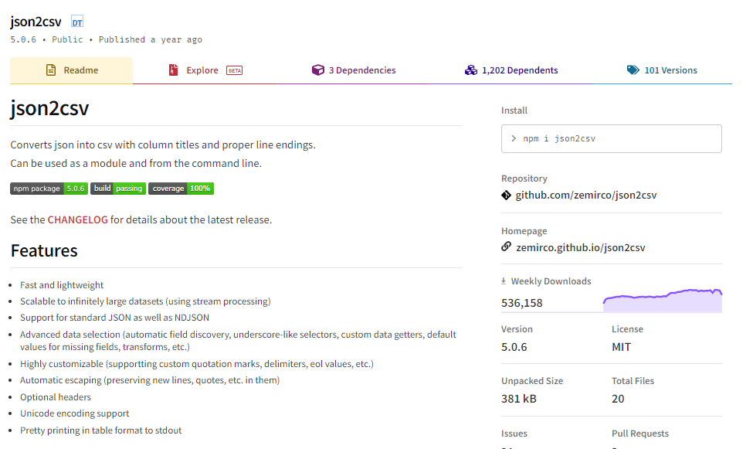

As you can see, we can install it by simply typing the following command into our code editor's terminal.

npm i json2csv

Now that we have this library, we can finally utilize it in our code, so go to the index.js file. Close the terminal, and instead of saving the data as JSON like we did before, we want to convert it into CSV data and then save it to the file, so for now, comment out the console log and return to the documentation to see how to import/use this library, as shown in the image below.

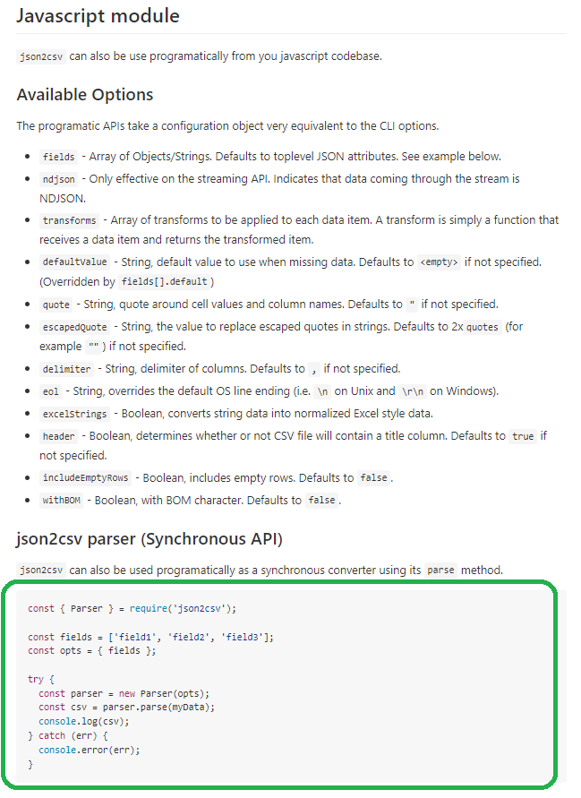

Copy the import command and paste it at the top of the code inside your code editor. Now, let's return to the documentation and look at an example. We have a great set of examples that could work for our situation.

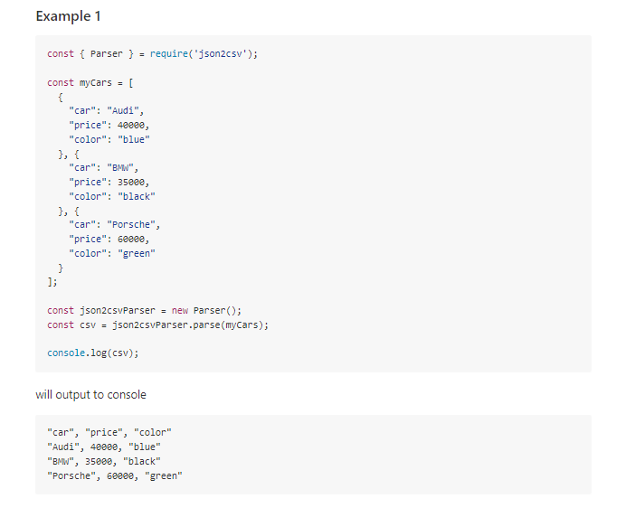

So we have an array of objects and we want to convert them to CSV data. In our case, we have two movie lists with multiple data in each of them, and we're going to convert those to CSV data. By looking at this example, you'd need to specify the fields of the JSON object that you want to have converted, and then basically input your data into it. So let's go ahead and test this out ourselves.

So, first, right before the console log, define a constant variable named csvDataKeys, and let's say we only want the title and the rating, imagePoster, and rating amount only from the data we have, hence copy and paste the exact following code into your index.js file right at the bottom before console log.

| const csvDataKeys = ["title", "rating", "imagePoster", "ratingAmount"];  const json2csvParser = new Parser({  fields: csvDataKeys,  });  const csv = json2csvParser.parse(moviesParseData); |
| --- |

We'll use the "moviesParseData" array to hold all the data, and if we did everything correctly, we should have a working CSV and instead of logging "moviesParseData" console log the actual CSV data, so let's start and run the debugger and see what we have. Of course, as you can see, it works properly; we have the “title” and “the rating”, "imagePoster" and "ratingAmount," as the keys and the actual results of the "moviesParseData".

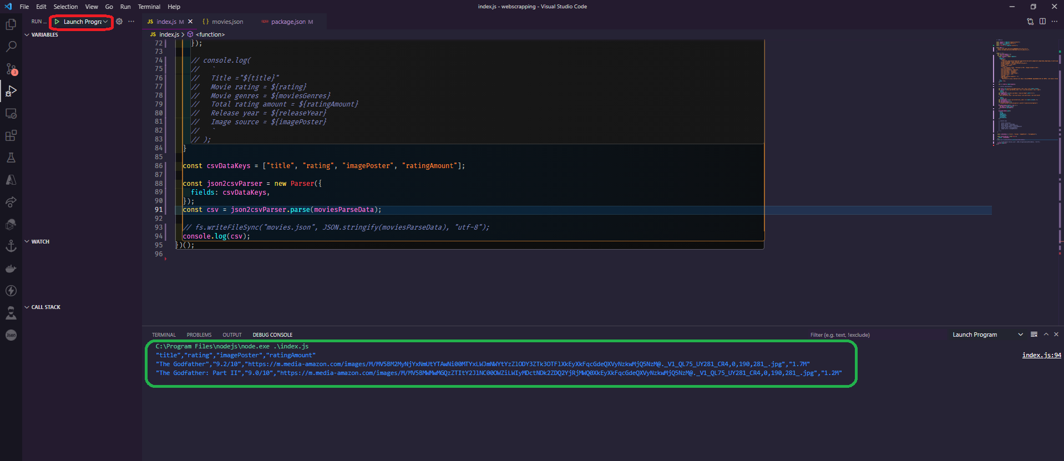

The only thing left is to save them in a file, which we can do easily with the command fsWriteFileSync, but instead of writing the data as "movies.json," we'll write it as CSV, so uncomment the line and replace it with "movies.csv," and instead of "JSON.stringify," output the CSV and save the file, and your final code should look like this.

| *// index.js*  const request = require("request-promise"); const cheerio = require("cheerio"); const fs = require("fs"); const { Parser } = require("json2csv");  const URLS = [  "https://www.imdb.com/title/tt0068646/?ref_=fn_al_tt_1",  "https://m.imdb.com/title/tt0071562/?ref_=tt_sims_tt_t_1", ];  (async () => {  let moviesParseData = [];  for (let url of URLS) {  const response = await request({  uri: url,  headers: {  "accept":  "text/html,application/xhtml+xml,application/xml;q=0.9,image/avif,image/webp,image/apng,*/*;q=0.8,application/signed-exchange;v=b3;q=0.9",  "accept-encoding": "gzip, deflate, br",  "accept-language": "en-IN,en-US;q=0.9,en;q=0.8",  "cache-control": "no-cache",  "pragma": "no-cache",  "sec-ch-ua":  '" Not A;Brand";v="99", "Chromium";v="96", "Google Chrome";v="96"',  "sec-ch-ua-mobile": "?1",  "sec-ch-ua-platform": "Android",  "sec-fetch-dest": "document",  "sec-fetch-mode": "navigate",  "sec-fetch-site": "same-origin",  "sec-fetch-user": "?1",  "sec-gpc": "1",  "upgrade-insecure-requests": "1",  "user-agent":  "Mozilla/5.0 (Linux; Android 6.0; Nexus 5 Build/MRA58N) AppleWebKit/537.36 (KHTML, like Gecko) Chrome/96.0.4664.110 Mobile Safari/537.36",  },  gzip: true,  });   let $ = cheerio.load(response);   // console.log(response);   let title = $("section.ipc-page-section > div > div > h1").text().trim();  let rating = $("div.ipc-button__text > div > div:nth-child(2) > div > span")  .text()  .slice(0, 6);  let imagePoster = $("div.ipc-media > img.ipc-image").attr("src");  let ratingAmount = $(  "div.ipc-button__text > div:last-child > div:last-child > div:last-child"  )  .text()  .slice(0, 4);  let releaseYear = $("li.ipc-inline-list__item > a").text().slice(0, 4);  let moviesGenres = [];  let movieGenresData = $(  'li[data-testid="storyline-genres"] a[href^="/search/title/?genres"]'  );  movieGenresData.each((i, elm) => {  let genre = $(elm).text();  moviesGenres.push(genre);  });   moviesParseData.push({  title,  rating,  imagePoster,  ratingAmount,  releaseYear,  moviesGenres,  });   // console.log(  // `  // Title ="${title}"  // Movie rating = ${rating}  // Movie genres = ${moviesGenres}  // Total rating amount = ${ratingAmount}  // Release year = ${releaseYear}  // Image source = ${imagePoster}  // `  // );  }   const csvDataKeys = ["title", "rating", "imagePoster", "ratingAmount"];   const json2csvParser = new Parser({  fields: csvDataKeys,  });  const csv = json2csvParser.parse(moviesParseData);   fs.writeFileSync("movies.csv", csv, "utf-8");  console.log(csv); })(); |
| --- |

After that, we should have a file generated, so let's run the debugger, and sure enough, we have a movies.csv file with all of the data we require.

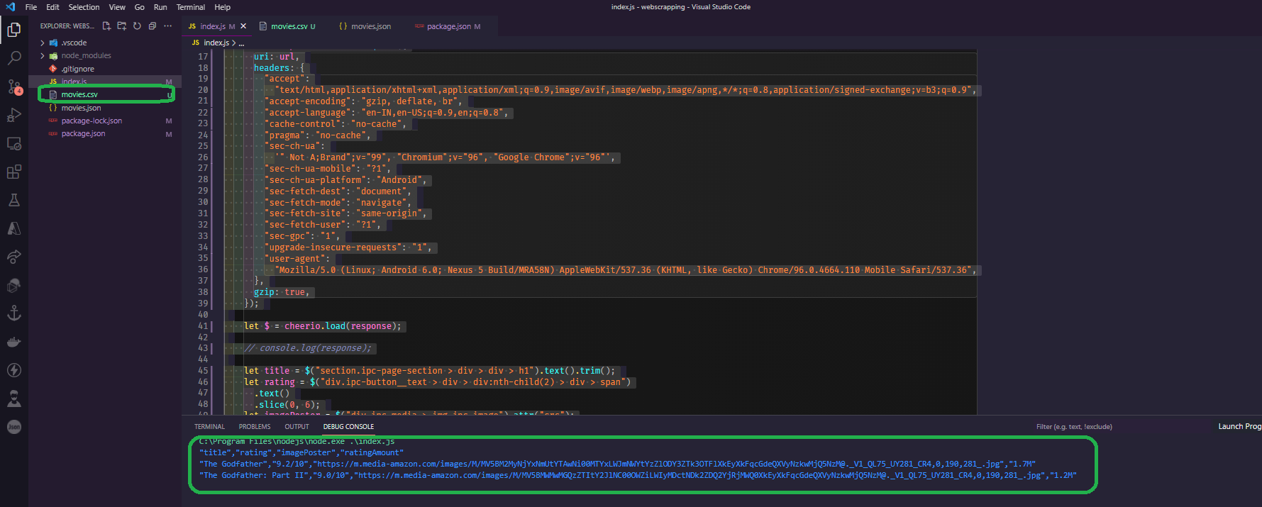

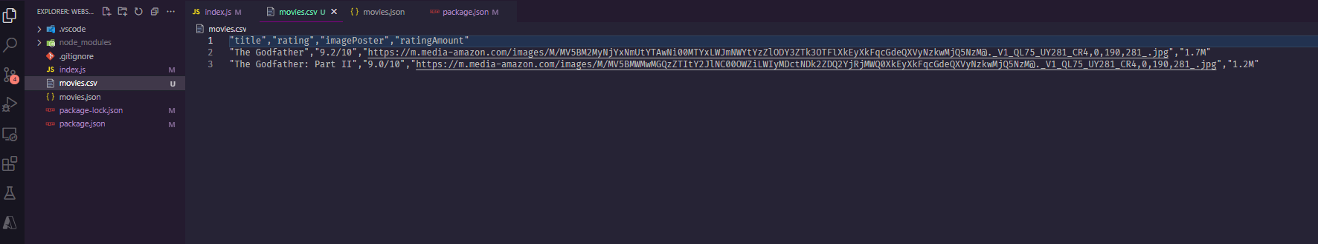

One small tip: if you don't want to provide any fields, or if you don't want to specify all of the fields, and you want to obtain everything from the array, you can simply remove everything from the array, and the code should look like this.

| const json2csvParser = new Parser();  const csv = json2csvParser.parse(moviesParseData);  fs.writeFileSync("movies.csv", csv, "utf-8");  console.log(csv); |
| --- |

**Shorthand technique to extract the selectors.**

Let's look at a simpler and faster way to gather selectors to scrape data from a website. This method is useful when you need to get something done quickly without having to worry too much about it. The only disadvantage is that it can be more vulnerable to errors. So, let's get this party started. Previously, when we wanted to scrape something from the IMDB scraper, we went to the website, used the inspector to look at the HTML structure, and then built a specific selector for that type of data. Let's look at an example. If we wanted to extract the title, we used a section with a class of ipc-page-section and then div with a class of TitleBlock, followed by other tags/elements, and then we needed to get the text, but this is a very long method.

section.ipc-page-section > div > div > h1

So, let's see what we can scrape for this example, let's say we wanted to get the movie plot, so what we can do is right-click inspect as we did previously, and what we can see right here is that the element that we want to scrape is a span containing some text.

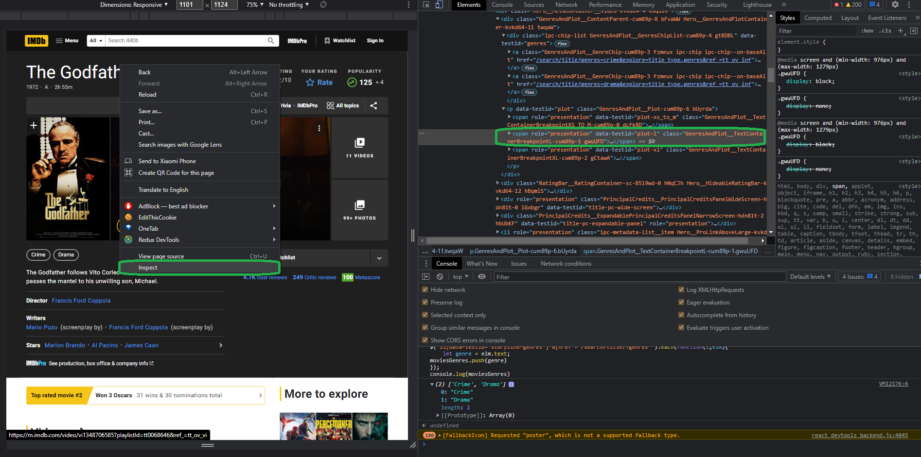

After that, what we want to do is scrape everything, and this is the simplest way to do it without overcomplicating things, so right-click on the element that we want to scrape, click on copy, and then copy selector by right-clicking on the selector and copying it. This implies that the browser will construct the selector for you and will apply its best reasoning to provide you with the results you desire.

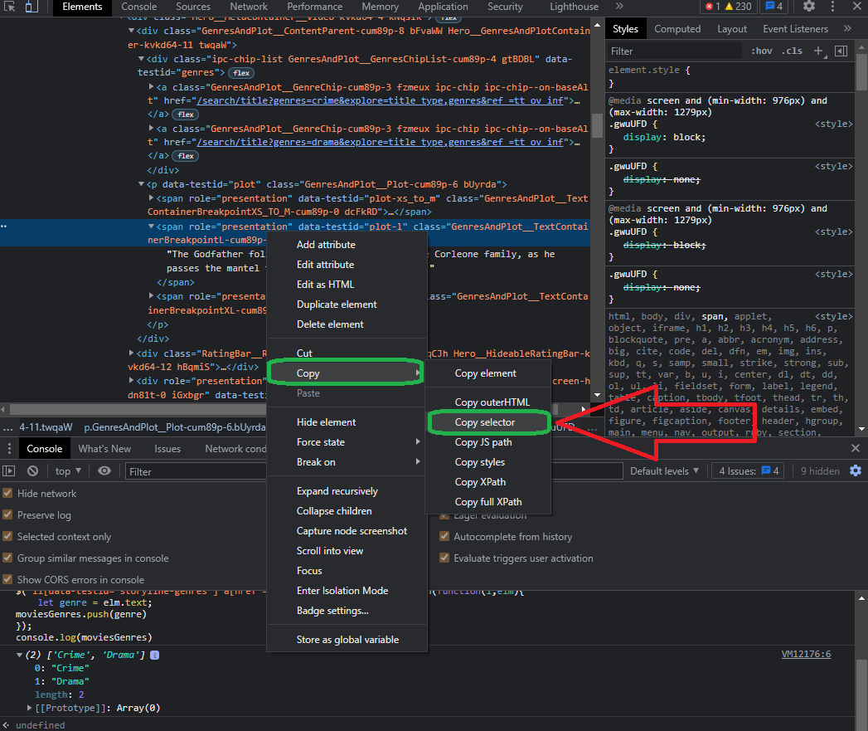

Let's try it out in our code editor as well, so go to the code and create a new variable called moviePlot, and then do it the same way we did before, copying everything and pasting it right here. We want to get the text and also trim it, so now that we have the variable, let's set a breakpoint right at it or simply console log it to see what the moviePlot variable is spitting out.

| let moviePlot = $("#__next > main > div.ipc-page-content-container.ipc-page-content-container--full.BaseLayout__NextPageContentContainer-sc-180q5jf-0.fWxmdE > section.ipc-page-background.ipc-page-background--base.TitlePage__StyledPageBackground-wzlr49-0.dDUGgO > section > div:nth-child(4) > section > section > div.Hero__MediaContentContainer__Video-kvkd64-2.kmTkgc > div.Hero__ContentContainer-kvkd64-10.eaUohq > div.Hero__MetaContainer__Video-kvkd64-4.kNqsIK > div.GenresAndPlot__ContentParent-cum89p-8.bFvaWW.Hero__GenresAndPlotContainer-kvkd64-11.twqaW > p > span.GenresAndPlot__TextContainerBreakpointL-cum89p-1.gwuUFD").text().trim()  console.log(moviePlot); |
| --- |

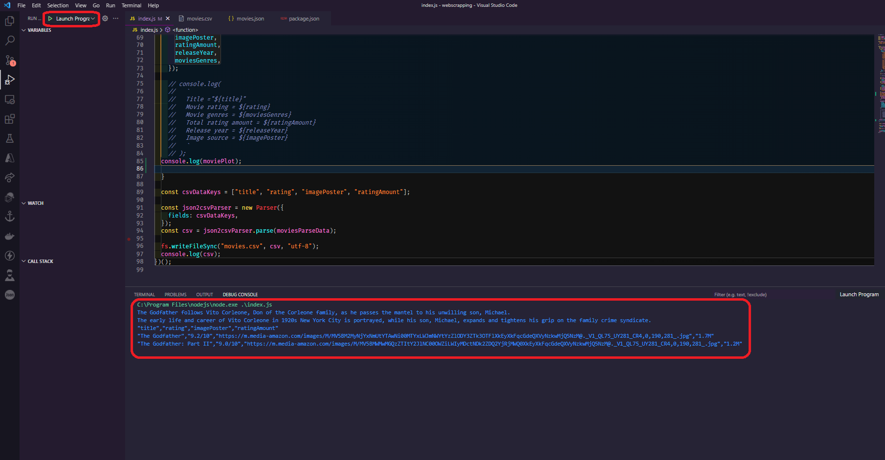

So, as you can see, all we had to do was copy and paste the selector generated by the Chrome browser. Of course, this is a lot easier than writing the selectors ourselves, and before we go any further, let's talk about the disadvantages of using this method versus the others we've discussed previously. There is no actual problem with using this method; no one is stopping you, but there is one thing to consider. As you can see, this selector is much larger than the others we constructed by hand. This is because the browser works its magic and tries to offer you the selector for the element it feels is the finest. However, there are far more selectors than are required. The disadvantage of having a lot of elements in your query is that the chances of it failing in the future are much higher. As you can see from what we wrote before, we used about one, two, or even three or four elements to scrape something, but in this case, we are using five, six, and seven elements to get that exact text. If one of those elements from the website changes, the query stops working, So, depending on the website and the circumstance, it's preferable to have two or three elements in our query selector than seven or even more. Always remember, the simpler the better. So, here's the question you might want to ask yourself: when would I choose one more than the other?

So, if you need to get something done quickly for any reason, or you know that a particular website doesn't change very often, you may use this copy and paste selection method. The beautiful thing about this method is that you don't even need to know how to write CSS selectors to build a scraper and this method may seem way easier and faster.

**Scraping and extracting the images locally**

In this segment, we'll learn how to more precisely download anything from a website and save it as a file. We'll go over how to get the image posters for all the movies that you wish to scrape.

First, a brief reminder that we'll be using the request library rather than the request-promise library we've been using up to this point. So, before we go any further, let's implement it right at the top, in the import area of the code, and just import the library.

| // index.js  const requestPromise = require("request-promise"); const cheerio = require("cheerio"); const fs = require("fs"); const { Parser } = require("json2csv"); const request = require("request"); |
| --- |

Also, don't forget to update the variable name from "request" to "requestPromise.". The reason we're using the request library rather than the request-promise library is that the request library is the original library dedicated to straightforward processing of the types of requests we make in Node. The request-promise library that we previously used is just a wrapper around the original request library, and it allows you to use the ES 2015 syntax with async-await instead of going into callback hell with the original library. This is the main reason we used request-promise rather than the request library itself for our scraper.

Now, before we get started on actually developing the scrapper for obtaining and storing images/posters, let's perform some fast preparation.

So, instead of an array of just strings, transform it into an array of objects. So, instead of just a URL as a string, make it an object and pass it URL prop and then close it, and then URL prop again for the next one and close it.

| const URLS = [  { url: "https://www.imdb.com/title/tt0068646/?ref_=fn_al_tt_1" },  { url: "https://m.imdb.com/title/tt0071562/?ref_=tt_sims_tt_t_1" }, ]; |
| --- |

Okay, to make this work with our current code, we'll simply alter the url because instead of passing in a string, we'll just pass in the object and access the url of this object, which will be the url that we defined.

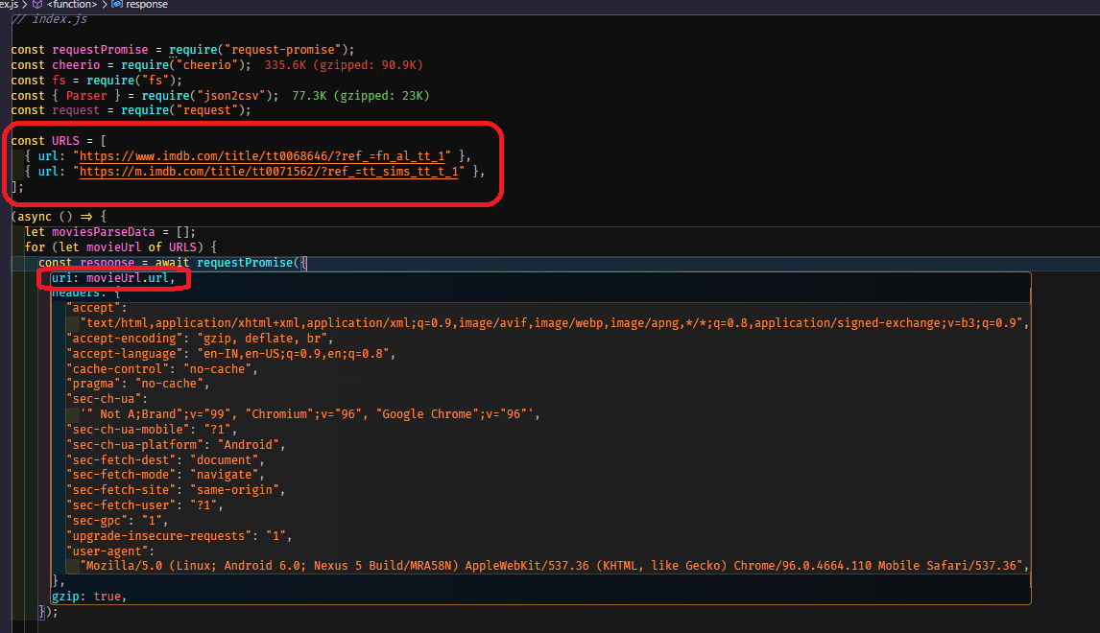

Also, the last section must be commented out because it is unnecessary and not required as of now.



Let's start actually writing some code, so let's say you want to download something from a website, say an image, a word document, music, or a pdf, you will basically need to create a file stream within node.js so that it can put data into it and build the actual file, so let's start and create a variable let's say it "imageExtractFile" which equals to file system and attach "createWriteStream" function and we only need to pass in a parameter related to the actual path of the file that we want to create, so keep in mind that we are in a for loop that iterates over each of the URLs that we are using, so we must use a dynamic file name; we can't just use "some_name.jpg" because it will be overwritten in the second call, and we only have one file.

| let imageExtractFile = fs.createWriteStream(`some_name.jpg`); |
| --- |

Before we go any further, we need to send in an id or anything for the actual file that we're going to utilize, so let's go to the top and add id, and simply pass in the movie name of this movie or something unique name, like "the godfather" and "the godfather 2".

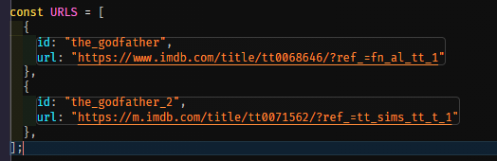

Now we can use these ids to create the actual file with these names, so let's go back and do that right here. We want to create a file with the name of the movie dot id and then we're going to put it as a jpeg. We need to specify it because we don't know what type of file it is when we're actually downloading it, and this will make it easier because we can find out what type of file it is from either the URL or from the request response, but for now, we'll presume it'll be a jpeg because we already know movie posters are jpeg, and we'll just pass in dot jpg. Now that we have this, we can test it out. However, before you do that, your code should look like this.

| let imageExtractFile = fs.createWriteStream(`${movieUrl.id}.jpg`); |
| --- |

and we should expect to see two files created on the system with the ids of the “the_godfather.jpg” and “the_godfather_2.jpg”, so let's do this quickly to make sure everything works, and then let's return to the files, where we find "the_godfather.jpg" and "the_godfather_2.jpeg," which is an empty file because we didn't pass any data into it.

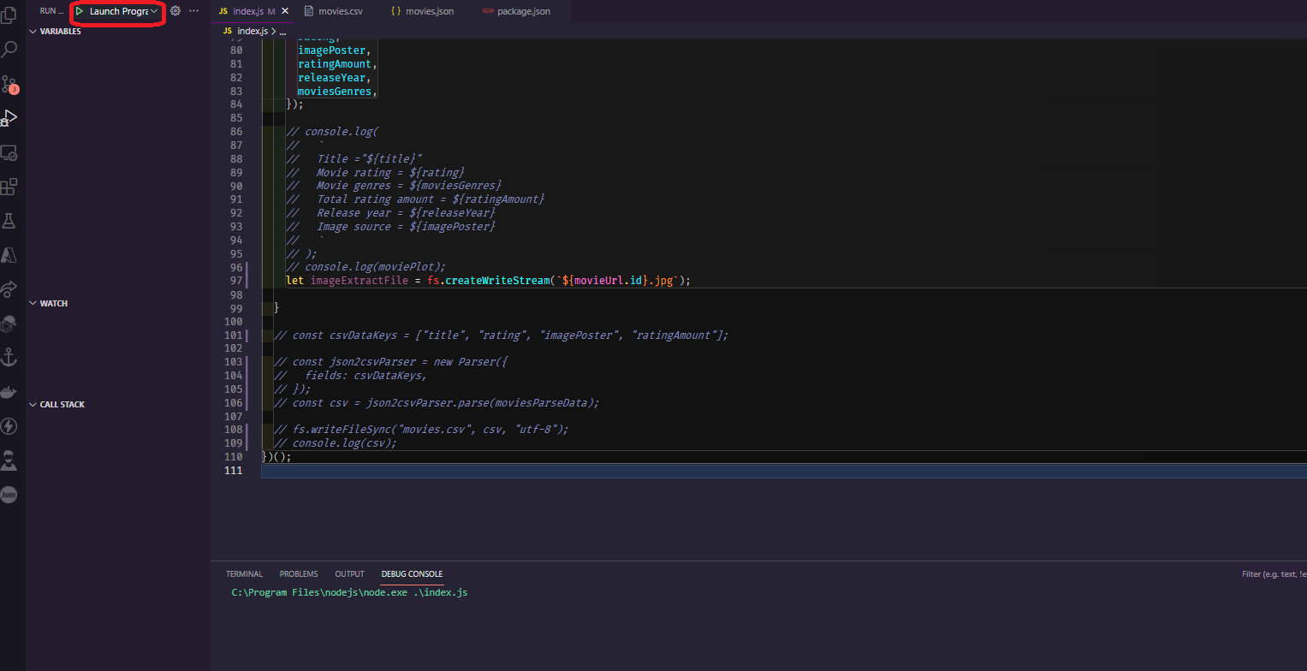

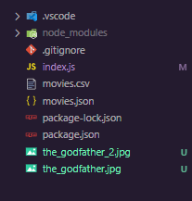

Now we need to take care of the request that goes to the server for the actual movie poster and then stream the data into our newly created files, so let's look at a quick example of how to stream data into a file. You need to make the same request as before, pass in the URL, and then use the pipe function to pass in the data to the newly created file that we previously did also with “createWriteStream”.

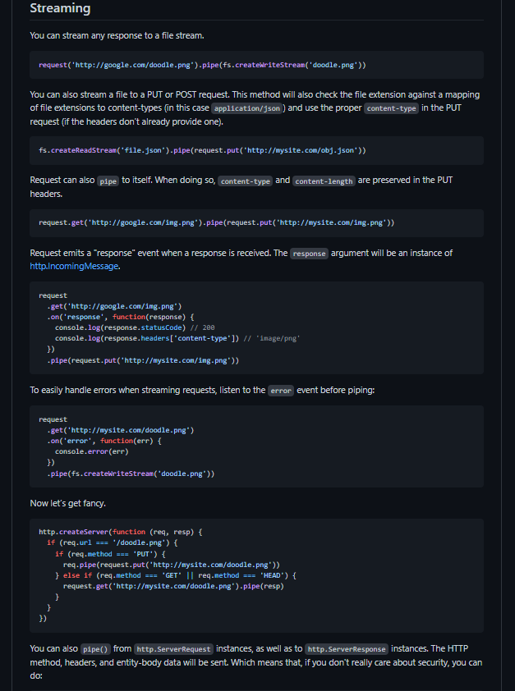

This is very simple, so let's get started. First, let's create a new variable called "streamImage," and then we'll use the request library to do the same thing we did previously in the URI, passing in the "movieUrl.imagePoster" which holds the image's actual link, and then for the headers, just copy-paste what we did above copy all of the. Copy all of the headers and paste them below. We only need to remove the HOST part of the code because the host isn't the IMDB main site URL; instead, the posters are using a S3 bucket from Amazon, which will cause some issues, so we'll just remove it. Also, don't forget to add the gzip. All right, right now we just want to pipe it out, so pipe it and then specify the actual imageExtractFile. Finally, here's what your code should look like now.

| // index.js  const requestPromise = require("request-promise"); const cheerio = require("cheerio"); const fs = require("fs"); const { Parser } = require("json2csv"); const request = require("request");  const URLS = [  {  id: "the_godfather",  url: "https://www.imdb.com/title/tt0068646/?ref_=fn_al_tt_1",  }  // {  // id: "the_godfather_2",  // url: "https://m.imdb.com/title/tt0071562/?ref_=tt_sims_tt_t_1",  // }, ];  (async () => {  let moviesParseData = [];  for (let movieUrl of URLS) {  const response = await requestPromise({  uri: movieUrl.url,  headers: {  "accept":  "text/html,application/xhtml+xml,application/xml;q=0.9,image/avif,image/webp,image/apng,*/*;q=0.8,application/signed-exchange;v=b3;q=0.9",  "accept-encoding": "gzip, deflate, br",  "accept-language": "en-IN,en-US;q=0.9,en;q=0.8",  "cache-control": "no-cache",  "pragma": "no-cache",  "sec-ch-ua":  '" Not A;Brand";v="99", "Chromium";v="96", "Google Chrome";v="96"',  "sec-ch-ua-mobile": "?1",  "sec-ch-ua-platform": "Android",  "sec-fetch-dest": "document",  "sec-fetch-mode": "navigate",  "sec-fetch-site": "same-origin",  "sec-fetch-user": "?1",  "sec-gpc": "1",  "upgrade-insecure-requests": "1",  "user-agent":  "Mozilla/5.0 (Linux; Android 6.0; Nexus 5 Build/MRA58N) AppleWebKit/537.36 (KHTML, like Gecko) Chrome/96.0.4664.110 Mobile Safari/537.36",  },  gzip: true,  });   let $ = cheerio.load(response);   // console.log(response);   let title = $("section.ipc-page-section > div > div > h1").text().trim();  let rating = $("div.ipc-button__text > div > div:nth-child(2) > div > span")  .text()  .slice(0, 6);  let imagePoster = $("div.ipc-media > img.ipc-image").attr("src");  let ratingAmount = $(  "div.ipc-button__text > div:last-child > div:last-child > div:last-child"  )  .text()  .slice(0, 4);  let releaseYear = $("li.ipc-inline-list__item > a").text().slice(0, 4);  let moviesGenres = [];  let movieGenresData = $(  'li[data-testid="storyline-genres"] a[href^="/search/title/?genres"]'  );  let moviePlot = $(  "#__next > main > div.ipc-page-content-container.ipc-page-content-container--full.BaseLayout__NextPageContentContainer-sc-180q5jf-0.fWxmdE > section.ipc-page-background.ipc-page-background--base.TitlePage__StyledPageBackground-wzlr49-0.dDUGgO > section > div:nth-child(4) > section > section > div.Hero__MediaContentContainer__Video-kvkd64-2.kmTkgc > div.Hero__ContentContainer-kvkd64-10.eaUohq > div.Hero__MetaContainer__Video-kvkd64-4.kNqsIK > div.GenresAndPlot__ContentParent-cum89p-8.bFvaWW.Hero__GenresAndPlotContainer-kvkd64-11.twqaW > p > span.GenresAndPlot__TextContainerBreakpointL-cum89p-1.gwuUFD"  )  .text()  .trim();  movieGenresData.each((i, elm) => {  let genre = $(elm).text();  moviesGenres.push(genre);  });   moviesParseData.push({  title,  rating,  imagePoster,  ratingAmount,  releaseYear,  moviesGenres,  });   // console.log(  // `  // Title ="${title}"  // Movie rating = ${rating}  // Movie genres = ${moviesGenres}  // Total rating amount = ${ratingAmount}  // Release year = ${releaseYear}  // Image source = ${imagePoster}  // `  // );  // console.log(moviePlot);  let imageExtractFile = fs.createWriteStream(`${movieUrl.id}.jpg`);   let streamImage = request({  url: movieUrl.imagePoster,  headers: {  "accept":  "text/html,application/xhtml+xml,application/xml;q=0.9,image/avif,image/webp,image/apng,*/*;q=0.8,application/signed-exchange;v=b3;q=0.9",  "accept-encoding": "gzip, deflate, br",  "accept-language": "en-IN,en-US;q=0.9,en;q=0.8",  "cache-control": "no-cache",  "pragma": "no-cache",  "sec-ch-ua":  '" Not A;Brand";v="99", "Chromium";v="96", "Google Chrome";v="96"',  "sec-ch-ua-mobile": "?1",  "sec-ch-ua-platform": "Android",  "sec-fetch-dest": "document",  "sec-fetch-mode": "navigate",  "sec-fetch-site": "same-origin",  "sec-fetch-user": "?1",  "sec-gpc": "1",  "upgrade-insecure-requests": "1",  "user-agent":  "Mozilla/5.0 (Linux; Android 6.0; Nexus 5 Build/MRA58N) AppleWebKit/537.36 (KHTML, like Gecko) Chrome/96.0.4664.110 Mobile Safari/537.36",  },  gzip: true,  }).pipe(imageExtractFile);  }   // const csvDataKeys = ["title", "rating", "imagePoster", "ratingAmount"];   // const json2csvParser = new Parser({  // fields: csvDataKeys,  // });  // const csv = json2csvParser.parse(moviesParseData);   // fs.writeFileSync("movies.csv", csv, "utf-8");  // console.log(csv); })(); |
| --- |

We actually have the code written and ready to go, but first, comment out the second movie because we only want to run it for the first movie. The reason for this is because we're in a for loop, and what's happening is that it's making the first request for the first movie, waiting for it to finish because we use the await syntax, and then it's going to make a request for the imagePoster is going to get saved to the file, but it will not wait for the entire process to complete before continuing; instead, it will immediately return to the top and make the second request, after which it will return to the bottom and which will collide. Hence, run it for a single movie and then deal with the issue later. Let's put it to the test and see how it goes, so fire up the debugger.

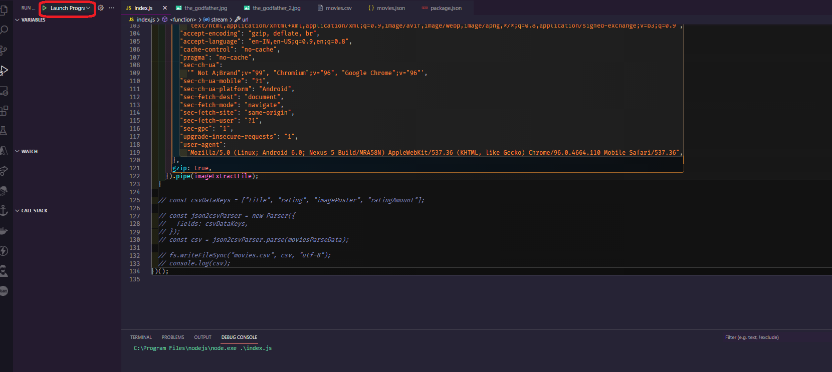

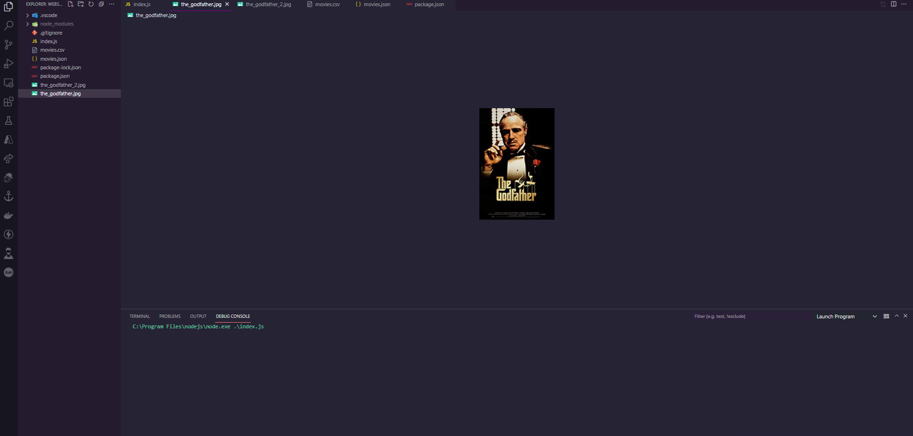

Now that we have the actual image downloaded, it appears that the_godfather.jpg is the actual image poster that we intended to extract. It completes the task as planned.

—------------------------------------------------------

**Promisify callback functions.**

Let's keep going with the image downloading part that we left off and see if we can address the problem we're having, so the main problem was that the downloading process starts, but it doesn't wait for it to finish before continuing. So, before we go any further, let's deep dive into “what is promisifying?”, so promisifying is the process of converting a non-promise function based on callbacks into a promise-returning function.

So let’s start fixing this issue, by default in node.js you can create your promise here is a quick example.

| let promisifyStuff = await new Promise((resolve,reject) => {  let alien = true;  if(alien){  resolve(true)  } else {  reject(false)  } }); |
| --- |

Let's imagine we're waiting for a new promise, and this function only has two parameters: resolve and reject. Let's say we have a variable called alien, and we're going to build a quick if statement that says if an alien is true, resolve with true and if not, reject with false.

Let's put everything into a variable and place a breakpoint at the end so we can observe what value that variable is spitting out. Let's run it quickly and test the value.

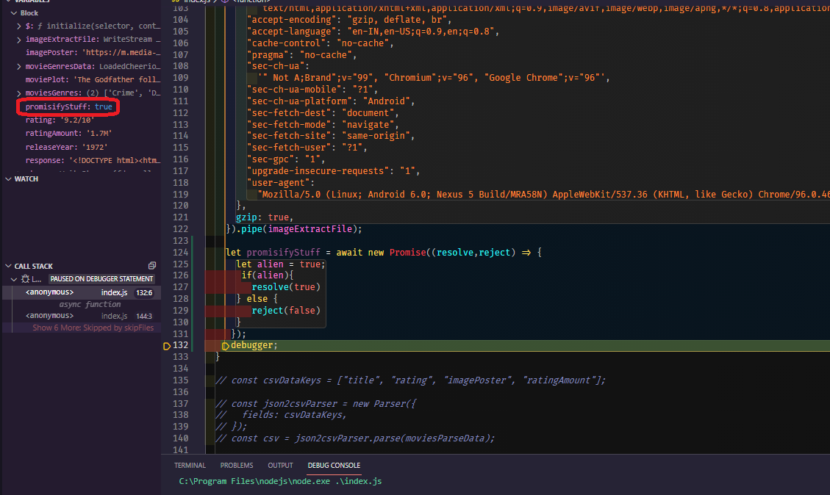

We have true since we checked to see if the alien is true and if it is, we resolve the promise using the function true, passing a string inside resolve, and then running it again, this "promisifyStuff" variable will be the exact string.

Let's see if we can quickly test it for the false as well, and see what we get when it rejects. Let's add a random string message in there and run it again, and we now receive an unhandled promise rejection error.

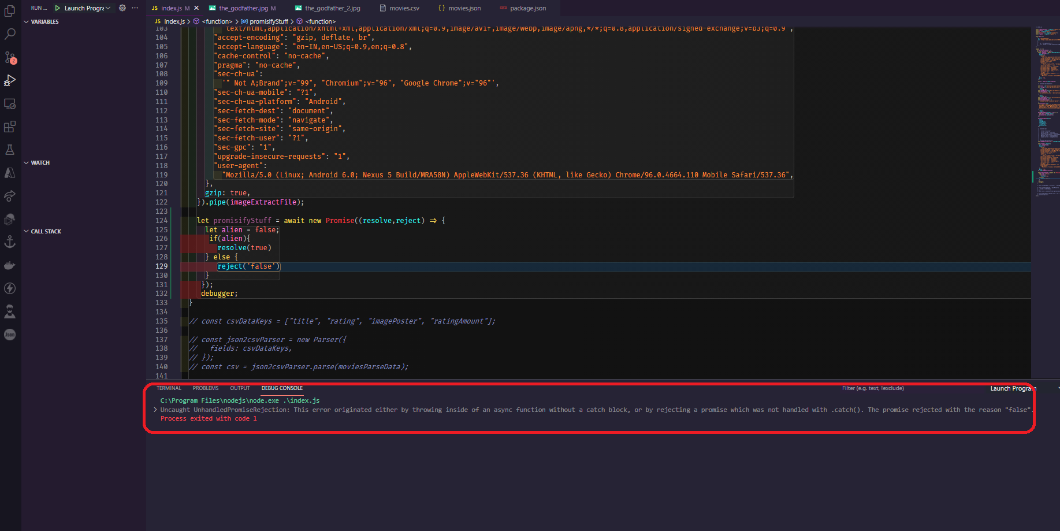

That's because we didn't catch the actual error. The reject throws an error, which we need to capture by wrapping it in a try-catch, then catching the error and console. log the error, and if we test again, the false message should be console logged.

| try {  let promisifyStuff = await new Promise((resolve, reject) => {  let alien = false;  if (alien) {  resolve(true);  } else {  reject("false");  }  });  } catch (error) {  console.log(error);  } |
| --- |

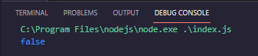

This was only a quick introduction to javascript promises, and it is highly advised that you investigate them further.

Let's return to our objective and start implementing this into what we need to accomplish. Basically, we need to wrap around this new promise thing into our stream request and let's get started right away. We'll just await a new Promise with resolve reject param and put it at the top of the streamImage, and then we'll end/wrap the promise. Now we need to figure out when the actual stream is completed. We can figure this out by adding an on() listener to an event. The event that we need to listen to is "finish," since after the request library is finished with the actual request, it will throw a finished event, which we need to grab onto. Now we'll just open up a function and declare a console. We'll log "some message or whatever custom message you want," and then we'll specify the resolve, which we'll say is true or you can leave them empty because we don't have to catch the message and we don't have to utilize it, so leaving it empty is fine. This is what your code should look like.

| // index.js  const requestPromise = require("request-promise"); const cheerio = require("cheerio"); const fs = require("fs"); const { Parser } = require("json2csv"); const request = require("request");  const URLS = [  {  id: "the_godfather",  url: "https://www.imdb.com/title/tt0068646/?ref_=fn_al_tt_1",  },  {  id: "the_godfather_2",  url: "https://m.imdb.com/title/tt0071562/?ref_=tt_sims_tt_t_1",  }, ];  (async () => {  let moviesParseData = [];  for (let movieUrl of URLS) {  const response = await requestPromise({  uri: movieUrl.url,  headers: {  "accept":  "text/html,application/xhtml+xml,application/xml;q=0.9,image/avif,image/webp,image/apng,*/*;q=0.8,application/signed-exchange;v=b3;q=0.9",  "accept-encoding": "gzip, deflate, br",  "accept-language": "en-IN,en-US;q=0.9,en;q=0.8",  "cache-control": "no-cache",  "pragma": "no-cache",  "sec-ch-ua":  '" Not A;Brand";v="99", "Chromium";v="96", "Google Chrome";v="96"',  "sec-ch-ua-mobile": "?1",  "sec-ch-ua-platform": "Android",  "sec-fetch-dest": "document",  "sec-fetch-mode": "navigate",  "sec-fetch-site": "same-origin",  "sec-fetch-user": "?1",  "sec-gpc": "1",  "upgrade-insecure-requests": "1",  "user-agent":  "Mozilla/5.0 (Linux; Android 6.0; Nexus 5 Build/MRA58N) AppleWebKit/537.36 (KHTML, like Gecko) Chrome/96.0.4664.110 Mobile Safari/537.36",  },  gzip: true,  });   let $ = cheerio.load(response);   // console.log(response);   let title = $("section.ipc-page-section > div > div > h1").text().trim();  let rating = $("div.ipc-button__text > div > div:nth-child(2) > div > span")  .text()  .slice(0, 6);  let imagePoster = $("div.ipc-media > img.ipc-image").attr("src");  let ratingAmount = $(  "div.ipc-button__text > div:last-child > div:last-child > div:last-child"  )  .text()  .slice(0, 4);  let releaseYear = $("li.ipc-inline-list__item > a").text().slice(0, 4);  let moviesGenres = [];  let movieGenresData = $(  'li[data-testid="storyline-genres"] a[href^="/search/title/?genres"]'  );  let moviePlot = $(  "#__next > main > div.ipc-page-content-container.ipc-page-content-container--full.BaseLayout__NextPageContentContainer-sc-180q5jf-0.fWxmdE > section.ipc-page-background.ipc-page-background--base.TitlePage__StyledPageBackground-wzlr49-0.dDUGgO > section > div:nth-child(4) > section > section > div.Hero__MediaContentContainer__Video-kvkd64-2.kmTkgc > div.Hero__ContentContainer-kvkd64-10.eaUohq > div.Hero__MetaContainer__Video-kvkd64-4.kNqsIK > div.GenresAndPlot__ContentParent-cum89p-8.bFvaWW.Hero__GenresAndPlotContainer-kvkd64-11.twqaW > p > span.GenresAndPlot__TextContainerBreakpointL-cum89p-1.gwuUFD"  )  .text()  .trim();  movieGenresData.each((i, elm) => {  let genre = $(elm).text();  moviesGenres.push(genre);  });   moviesParseData.push({  title,  rating,  imagePoster,  ratingAmount,  releaseYear,  moviesGenres,  });   console.log(  `  Title ="${title}"  Movie rating = ${rating}  Movie genres = ${moviesGenres}  Total rating amount = ${ratingAmount}  Release year = ${releaseYear}  Image source = ${imagePoster}  `  );  console.log(moviePlot);  let imageExtractFile = fs.createWriteStream(`${movieUrl.id}.jpg`);   await new Promise((resolve, reject) => {  let streamImage = request({  url: imagePoster,  headers: {  "accept":  "text/html,application/xhtml+xml,application/xml;q=0.9,image/avif,image/webp,image/apng,*/*;q=0.8,application/signed-exchange;v=b3;q=0.9",  "accept-encoding": "gzip, deflate, br",  "accept-language": "en-IN,en-US;q=0.9,en;q=0.8",  "cache-control": "no-cache",  "pragma": "no-cache",  "sec-ch-ua":  '" Not A;Brand";v="99", "Chromium";v="96", "Google Chrome";v="96"',  "sec-ch-ua-mobile": "?1",  "sec-ch-ua-platform": "Android",  "sec-fetch-dest": "document",  "sec-fetch-mode": "navigate",  "sec-fetch-site": "same-origin",  "sec-fetch-user": "?1",  "sec-gpc": "1",  "upgrade-insecure-requests": "1",  "user-agent":  "Mozilla/5.0 (Linux; Android 6.0; Nexus 5 Build/MRA58N) AppleWebKit/537.36 (KHTML, like Gecko) Chrome/96.0.4664.110 Mobile Safari/537.36",  },  gzip: true,  })  .pipe(imageExtractFile)  .on("finish", () => {  console.log("Movie Poster Image downloaded");  resolve();  });  });  }   const csvDataKeys = ["title", "rating", "imagePoster", "ratingAmount"];   const json2csvParser = new Parser({  fields: csvDataKeys,  });  const csv = json2csvParser.parse(moviesParseData);   fs.writeFileSync("movies.csv", csv, "utf-8");  console.log(csv); })(); |
| --- |

If we execute this, the scraper will go to the first movie and ask for the details, parse them, and then go to the "streamImage" and start downloading and waiting for it to finish, before repeating the process for the second movie. Let's run through the procedure quickly and see what happens. We should see a message that says "Movie Poster Image downloaded" and then another message that says the same thing.

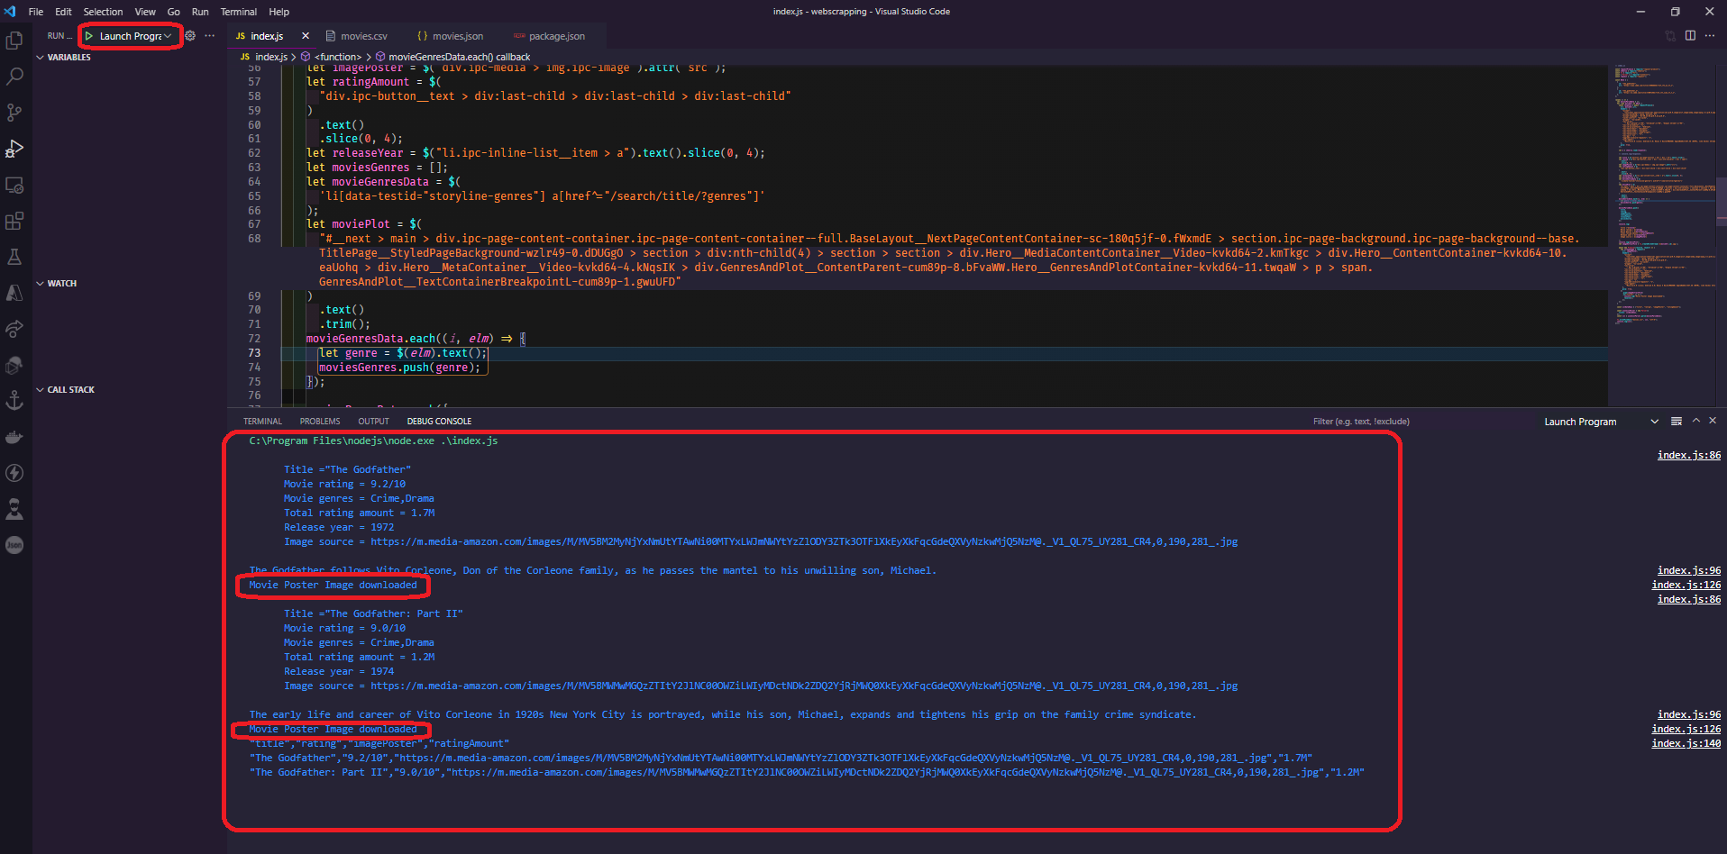

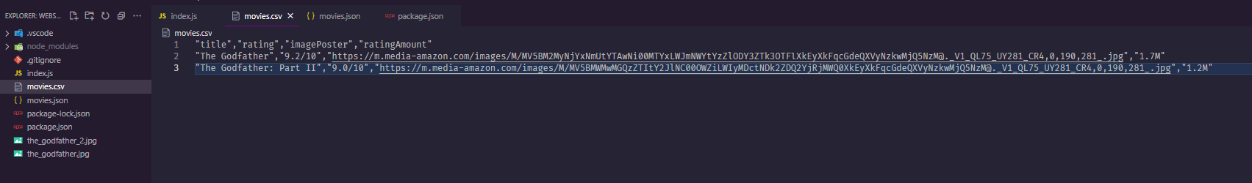

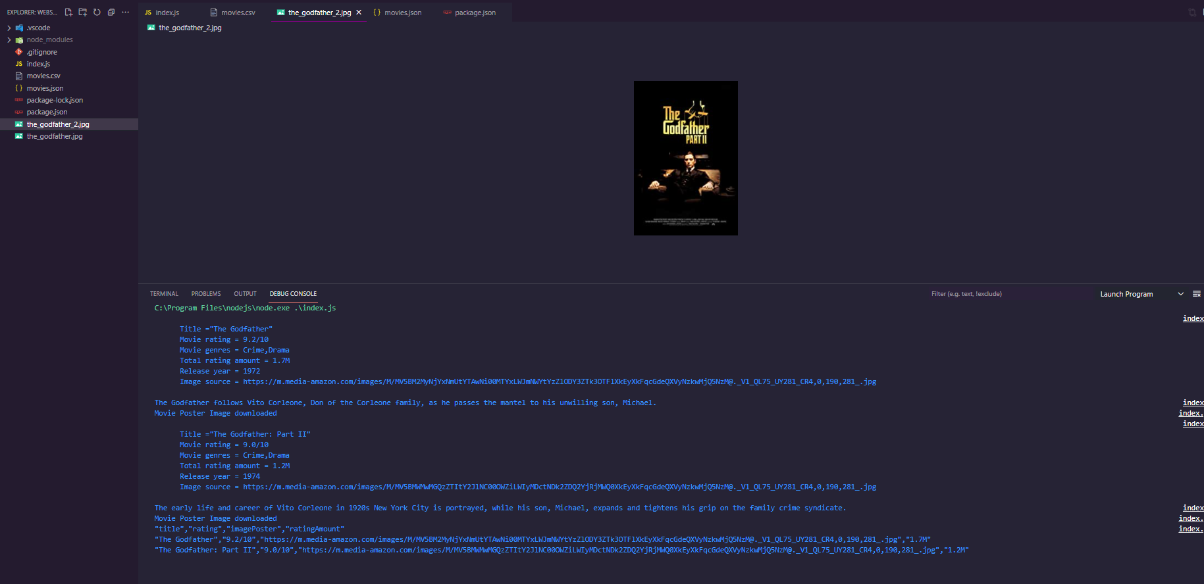

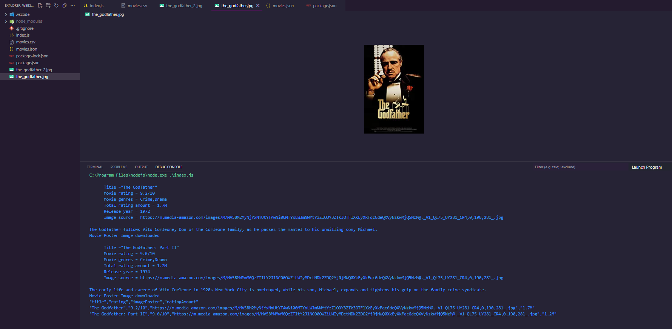

Finally, we're almost done, but we need to handle the fact that it can fail and throw an error, so let's create another on listener and just listen for an error, and then we'll have a function that takes an error parameter and then we'll reject the promise with the actual error that we get, and now that we've rejected the promise with the actual error that we get, we just need to catch it, so simply specify the catch method, then we'll receive the error, and then we'll console.log the error to record and display the error message itself.

| await new Promise((resolve, reject) => {  let streamImage = request({  url: imagePoster,  headers: {  "accept": "text/html,application/xhtml+xml,application/xml;q=0.9,image/avif,image/webp,image/apng,*/*;q=0.8,application/signed-exchange;v=b3;q=0.9",  "accept-encoding": "gzip, deflate, br",  "accept-language": "en-IN,en-US;q=0.9,en;q=0.8",  "cache-control": "no-cache",  "pragma": "no-cache",  "sec-ch-ua":  '" Not A;Brand";v="99", "Chromium";v="96", "Google Chrome";v="96"',  "sec-ch-ua-mobile": "?1",  "sec-ch-ua-platform": "Android",  "sec-fetch-dest": "document",  "sec-fetch-mode": "navigate",  "sec-fetch-site": "same-origin",  "sec-fetch-user": "?1",  "sec-gpc": "1",  "upgrade-insecure-requests": "1",  "user-agent":  "Mozilla/5.0 (Linux; Android 6.0; Nexus 5 Build/MRA58N) AppleWebKit/537.36 (KHTML, like Gecko) Chrome/96.0.4664.110 Mobile Safari/537.36", },  gzip: true,  })  .pipe(imageExtractFile)  .on("finish", () => {  console.log("Movie Poster Image downloaded");  resolve();  })  .on("error", (err) => {  console.log(err);  reject(error);  })  }).catch((err) => {  console.log(err);  }); |
| --- |

Finally, we can identify which specific movie an error occurred in by simply replacing the single quotes with backticks, allowing us to use the javascript syntax inside it to designate the individual “movie.id” of the error so that future debugging becomes really very simple. So this is how the final code should look like.

| // index.js  const requestPromise = require("request-promise"); const cheerio = require("cheerio"); const fs = require("fs"); const { Parser } = require("json2csv"); const request = require("request");  const URLS = [  {  id: "the_godfather",  url: "https://www.imdb.com/title/tt0068646/?ref_=fn_al_tt_1",  },  {  id: "the_godfather_2",  url: "https://m.imdb.com/title/tt0071562/?ref_=tt_sims_tt_t_1",  }, ];  (async () => {  let moviesParseData = [];  for (let movieUrl of URLS) {  const response = await requestPromise({  uri: movieUrl.url,  headers: {  "accept":  "text/html,application/xhtml+xml,application/xml;q=0.9,image/avif,image/webp,image/apng,*/*;q=0.8,application/signed-exchange;v=b3;q=0.9",  "accept-encoding": "gzip, deflate, br",  "accept-language": "en-IN,en-US;q=0.9,en;q=0.8",  "cache-control": "no-cache",  "pragma": "no-cache",  "sec-ch-ua":  '" Not A;Brand";v="99", "Chromium";v="96", "Google Chrome";v="96"',  "sec-ch-ua-mobile": "?1",  "sec-ch-ua-platform": "Android",  "sec-fetch-dest": "document",  "sec-fetch-mode": "navigate",  "sec-fetch-site": "same-origin",  "sec-fetch-user": "?1",  "sec-gpc": "1",  "upgrade-insecure-requests": "1",  "user-agent":  "Mozilla/5.0 (Linux; Android 6.0; Nexus 5 Build/MRA58N) AppleWebKit/537.36 (KHTML, like Gecko) Chrome/96.0.4664.110 Mobile Safari/537.36",  },  gzip: true,  });   let $ = cheerio.load(response);   // console.log(response);   let title = $("section.ipc-page-section > div > div > h1").text().trim();  let rating = $("div.ipc-button__text > div > div:nth-child(2) > div > span")  .text()  .slice(0, 6);  let imagePoster = $("div.ipc-media > img.ipc-image").attr("src");  let ratingAmount = $(  "div.ipc-button__text > div:last-child > div:last-child > div:last-child"  )  .text()  .slice(0, 4);  let releaseYear = $("li.ipc-inline-list__item > a").text().slice(0, 4);  let moviesGenres = [];  let movieGenresData = $(  'li[data-testid="storyline-genres"] a[href^="/search/title/?genres"]'  );  let moviePlot = $(  "#__next > main > div.ipc-page-content-container.ipc-page-content-container--full.BaseLayout__NextPageContentContainer-sc-180q5jf-0.fWxmdE > section.ipc-page-background.ipc-page-background--base.TitlePage__StyledPageBackground-wzlr49-0.dDUGgO > section > div:nth-child(4) > section > section > div.Hero__MediaContentContainer__Video-kvkd64-2.kmTkgc > div.Hero__ContentContainer-kvkd64-10.eaUohq > div.Hero__MetaContainer__Video-kvkd64-4.kNqsIK > div.GenresAndPlot__ContentParent-cum89p-8.bFvaWW.Hero__GenresAndPlotContainer-kvkd64-11.twqaW > p > span.GenresAndPlot__TextContainerBreakpointL-cum89p-1.gwuUFD"  )  .text()  .trim();  movieGenresData.each((i, elm) => {  let genre = $(elm).text();  moviesGenres.push(genre);  });   moviesParseData.push({  title,  rating,  imagePoster,  ratingAmount,  releaseYear,  moviesGenres,  });   console.log(  `  Title ="${title}"  Movie rating = ${rating}  Movie genres = ${moviesGenres}  Total rating amount = ${ratingAmount}  Release year = ${releaseYear}  Image source = ${imagePoster}  `  );  console.log(moviePlot);  let imageExtractFile = fs.createWriteStream(`${movieUrl.id}.jpg`);   await new Promise((resolve, reject) => {  let streamImage = request({  url: imagePoster,  headers: {  "accept":  "text/html,application/xhtml+xml,application/xml;q=0.9,image/avif,image/webp,image/apng,*/*;q=0.8,application/signed-exchange;v=b3;q=0.9",  "accept-encoding": "gzip, deflate, br",  "accept-language": "en-IN,en-US;q=0.9,en;q=0.8",  "cache-control": "no-cache",  "pragma": "no-cache",  "sec-ch-ua":  '" Not A;Brand";v="99", "Chromium";v="96", "Google Chrome";v="96"',  "sec-ch-ua-mobile": "?1",  "sec-ch-ua-platform": "Android",  "sec-fetch-dest": "document",  "sec-fetch-mode": "navigate",  "sec-fetch-site": "same-origin",  "sec-fetch-user": "?1",  "sec-gpc": "1",  "upgrade-insecure-requests": "1",  "user-agent":  "Mozilla/5.0 (Linux; Android 6.0; Nexus 5 Build/MRA58N) AppleWebKit/537.36 (KHTML, like Gecko) Chrome/96.0.4664.110 Mobile Safari/537.36",  },  gzip: true,  })  .pipe(imageExtractFile)  .on("finish", () => {  console.log(`Movie Poster Image of ${movieUrl.id} is downloaded`);  resolve();  })  .on("error", (err) => {  console.log(err);  reject(error);  })  }).catch((err) => {  console.log(`${movieUrl.id} image download error ${err}`);  });  }   const csvDataKeys = ["title", "rating", "imagePoster", "ratingAmount"];   const json2csvParser = new Parser({  fields: csvDataKeys,  });  const csv = json2csvParser.parse(moviesParseData);   fs.writeFileSync("movies.csv", csv, "utf-8");  console.log(csv); })(); |
| --- |

Let's do a final check to see if we have a great and curated console error message. So far, everything is working fine, and we've learnt a lot and gone to the depths of scraping from the ground up.

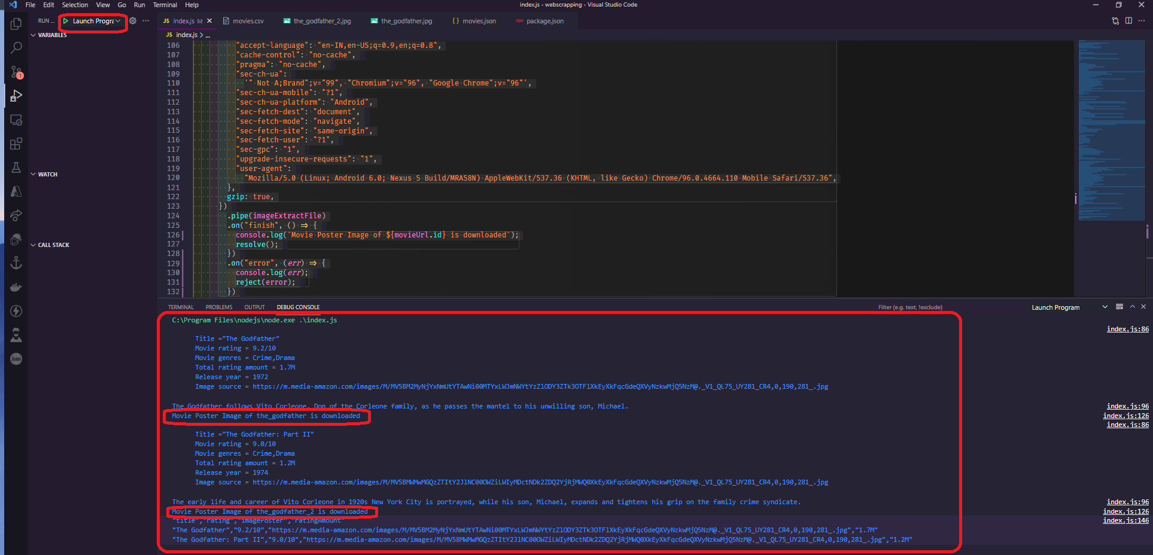

**The complete source code is available here:**

[**https://github.com/pramit-marattha/web-scraping**](https://github.com/pramit-marattha/web-scraping)

**Conclusion:**

In this article, we learned about scraping from the ground up, including Nodejs and the fundamentals of javascript, why and when to scrape a website, the most common problems with scraping, different scraping methods such as to request method and browser automation method, and finally how to scrape the data from the IMDB website in extensive detail, as well as how to export scraped data into CSV and JSON files. If you wish to pursue a career in web scraping, this article may be very useful.